Get Started with Pearson’s
Mastering Biology
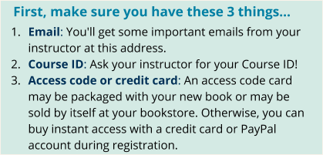

Next, get registered and join your course!
- Go to Pearson Mastering Biology webpage (https://www.pearsonmylabandmastering.com/masteringbiology/).
- Under Register Now, select Student.
- Confirm you have the information needed, then select OK! Register now.
- Enter your instructor’s Course ID (MBWINGARD7549902), and choose Continue.
- Enter your existing Pearson account username and password and select Sign in. You have an account if you’ve ever used a Pearson MyLab & Mastering product, such as MyLab Math, MyLab IT, or Mastering Chemistry.
  - If you don’t have an account, select Create and complete the required fields.
- Enter the access code (SSPREN-SIRUP-SERRY-GIGUE-FIORI-HOMES).
- From the “You’re Done!” page, select Go to My Courses.
- Select Yes and enter your Course ID to join your course. Click Continue.
- If asked, enter your Student ID according to the instructions provided and click Continue. That’s it! You should see the course home page for the course.

To sign in later:
- Go to Pearson Mastering Biology webpage and select Sign In.
- Enter your Pearson account username and password from registration, and select Sign In.
  - If you forgot your username or password, select Forgot your username or password?

To join another course for the same textbook (no additional purchase needed):
- Sign in with the username and password that you specified during registration.
- Select My Courses in the upper left and then choose .
- Enter the Course ID from your instructor and click Continue.
- If asked, enter your Student ID according to the instructions provided and click Continue.
- To switch courses, select My Courses from the course menu (left side).
- Select any active course link that appears below Switch to another course.
- The next time you sign in to Mastering, your course view will match the last course you chose.

If you have a technical issue: Contact Pearson Support.

