Chapter 4 Review KEY Name: ___________________________ Per. __
Integrated Science: Physics/Design

- Define speed.
Speed describes how quickly something moves.

- What is the formula for speed?
Speed = distance/time

- What are the units for speed?
The units for speed are distance units over time units.

- What is the difference between instantaneous speed and average speed?
The average speed is calculated by dividing the total distance of a trip by the time the trip took. The instantaneous speed is the actual speed on object has at any moment.

- An object travels 30 meters in 5 seconds. What is its speed?
S= d/t
S= 30m/5 sec
S=6 m/s

- How long would it take a cat to travel 200 meters if its speed was 10 m/s?
t=d/s
t= 200m ÷ 10 m/s
t= 20s

- What distance could a bird travel in 25 seconds if it was flying at 10 m/s?
d= s x t
d= 10 m/s x 25 s
d = 250 m

- A train travels 50.0 km in 3.00 hours. What is the average speed of the train? (Be sure and report your answer to the correct number of significant digits.)
S=d/t
S=50.0 km / 3.00 hr
S= 16.6666666 km/hr
The answer must have 3 significant digits, so round the speed to 16.7 km/hr

(You can find more speed practice problems on page 77 of your textbook.)

- Define velocity.
Velocity is a vector quantity that includes both speed and direction.

- What is the difference between speed and velocity?
Speed just describes how quickly something moves. Velocity describes both how quickly and in what direction something moves.

- Is velocity a vector? Why or why not?
Velocity is a vector because it has both magnitude and direction.

- Can velocity change when speed stays constant? Explain.
Yes, if an object is traveling at a constant speed and it changes direction then its velocity will change.

- Can speed change when velocity stays constant? Explain.
No, if the speed changes then the velocity will also change because speed is a part of velocity.

- Define acceleration.
Acceleration is the rate of change in velocity

- What is the equation for determining acceleration?
a = V _{finish} – V _{start} / Time

- A jogger slows down from 10 m/s to 6 m/s in 10 seconds. What is her acceleration?
a = 6 m/s – 10 m/s ÷ 10 s
a = -0.4 m/s²

- A boat goes from 3.3 m/s to 11 m/s. in 4.0 seconds. What is the boat’s acceleration? (Be sure your answer has the correct number of significant digits.)
a = 11 m/s – 3.3 m/s ÷ 4 s
a = 1.925 m/s²
The answer can only have two significant digits so it should be rounded to 1.9 m/s²

- A skateboarder traveling at 4.0 meters per second rolls to a stop at the top of a ramp in 2.0 seconds. What is the skateboarder’s acceleration?
a = 0 m/s – 4.0 m/s ÷ 2.0 s
a = -2.0 m/s²

(You can find more acceleration problems on page 88 of your textbook)

- If a racecar driver goes at a constant speed as she rounds a corner, is she accelerating? Explain.
The driver is accelerating because her direction is changing.

- If a hockey player goes at a constant speed in a straight line, is he accelerating? Explain.
The hockey player is not accelerating because his velocity is not changing.

- If a marathon runner puts on a burst of speed at the end of a race, is he accelerating? Explain.
The runner is accelerating because his speed is changing.

- If a cat stops suddenly, is it accelerating? Explain.
The cat is accelerating its speed is changing.

Use the graph to answer the questions 23-29.

- Which rabbit went the farthest?
Rabbit #2 (red)

- Which rabbit went the longest amount of time?
All the rabbits went for the same amount of time

- Which rabbit(s) was/were going at a constant velocity?
Rabbits 2 and 3 (Red and Blue)

- Which rabbit(s) slowed down?
Rabbit #1 (green)

- Which rabbit went fastest in the 1st 3 seconds of the race?
Rabbit #1 (green)

- Which rabbit(s) went backwards?
None of the rabbits went backwards.

- Which rabbit(s) was/were accelerating?
Rabbit #1 (green)

Below is a speed vs. time graph that shows the speed of a student walking around the school. Use the graph to answer questions 30 – 34.
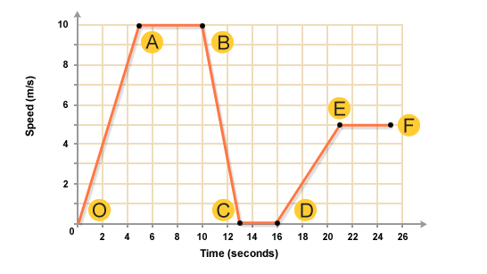

- What part of the graph shows the student speeding up?
O-A
D-E

- What part of the graph shows the student slowing down?
B-C

- What part of the graph shows the student stopped?
C-D

- What part of the graph shows the student going the fastest?
A-B

- What part of the graph shows the student going at a constant speed?
A-B
C-D
E-F

- What is the acceleration due to gravity?
9.8 m/s²

- A rock is in a freefell after being knocked off the edge of a cliff.
  - How fast will the rock be going in one second?
9.8 m/s
  - How fast will the rock be going in two seconds?
19.6 m/s
  - How fast will the rock be going in three seconds?
29.4 m/s
  - How fast will the rock be going in four seconds?
39.2 m/s

