**TLDR (Too Long, Didn’t Read) for Chapter 4 Arrangement of Electrons in Atoms**

**TLDR 4.1 The Development of a New Atomic Model (pp. 97-103)**

Light was considered to be a wave-phenomenon up until Albert Einstein explained the photoelectric effect in 1905, in which photons exhibited particle-like behavior. This wave-particle duality is common among small, fundamental particles of matter such as photons and electrons. We are going to focus on the wave-nature of light in this section.

The wave speed of an emanating wave can be described with the following equation

Wave speed = wavelength x frequency of oscillation

Speed = l x f

The wavelength is defined as the distance from peak to peak or trough to trough of a complete wave cycle. The frequency is defined as the number of full wave cycles per second. In the SI system the units of frequency are 1/s or s-1, and are so common that they have been given a special name, the Hertz (Hz for short).

**Example**

A buoy in the ocean is found to bob up to maximum height once every 6.00 seconds. If the distance between ocean wave crests is 20.0 meters, calculate the wave speed of the incoming ocean waves.

**Answer:**

Wave speed = wavelength x frequency = 20.0 m x 1cycle/6 seconds = 3.33 m/s.

For electromagnetic radiation, which is just a fancy way of saying “photons”, there are some special Greek letters used, but the fundamental wave speed equation is exactly the same as that for ocean waves.

Wave speed of a photon = wavelength x frequency

c = λν

where: λ (‘lambda’ = wave length (m)

& ν (‘nu’= frequency (s-1)

One notable difference in ocean waves and waves of electromagnetic radiation is that the photons in an e/m wave all travel at the same speed in the same type of material, regardless of color or wavelength. The speed of light in a vacuum is 3.00 x 108 m/s, and this is the number we will consistently apply when solving problems involving photons.

There are three primary equations used to answer questions involving frequency, wavelength and energy of electromagnetic radiation, we’ve already seen the first one:

**Wave speed of electromagnetic radiation:**

c = λν

**Energy of a photon (in terms of frequency)**

Ephoton = hν

Where: h = 6.626 x 10-34 J۰s [aka “Planck’s constant]

**Energy of a photon (in terms of wavelength)**

$$E_{photon}=\frac{hc}{ν}$$

In the early 1900’s it was becoming apparent that electrons around atoms were confined to specific distances and energy states around atomic nuclei. It was also apparent that these electrons could not just absorb any old amount of energy (in the form of photons), but rather they required certain fixed amounts of energy in order to reach a higher energy level. The situation is similar to that of a step ladder, in that a step ladder is designed to only accept full steps worth of input, or an integer number of step heights. Imagine what you would look like if you tried to put in 50 half-steps into a step ladder. Would you go anywhere? This fixed step-height issue in ladders is similar to the energy profile of an electron around an atom. The fact that the electron (and the step ladder) can only accept discrete, certain amounts (quanta) of energy means that the ladder and the electron around an atom are “quantized” with respect to energy. [***fun fact: “quanta” is plural, “quantum” is singular***]

Electrons in matter absorb a quantum (like a stair-step length on a ladder) of electromagnetic radiation (photons) and increase their energy if the photon is sufficiently energetic. If an electron falls from a higher energy level to a lower level, it produces a photon of exactly the same energy as the difference between the levels. This process is depicted in the illustration below:

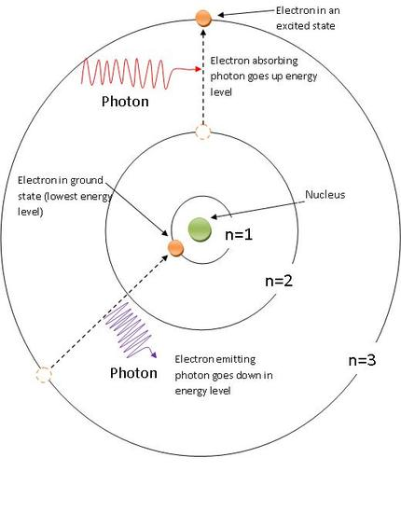

**Example problems:**

Looking at the three equations listed above, we can make some generalizations about the energy, wavelength and frequency of electromagnetic radiation. Look at these equations and circle the appropriate word that correctly completes each statement below.

The longer the wavelength the *higher / low*er the energy of the photon.

The higher the frequency the *higher / lower* the energy of the photon.

The higher the wavelength, the *higher / lower* the frequency of the photon.

Use your results above to answer the question posted below.

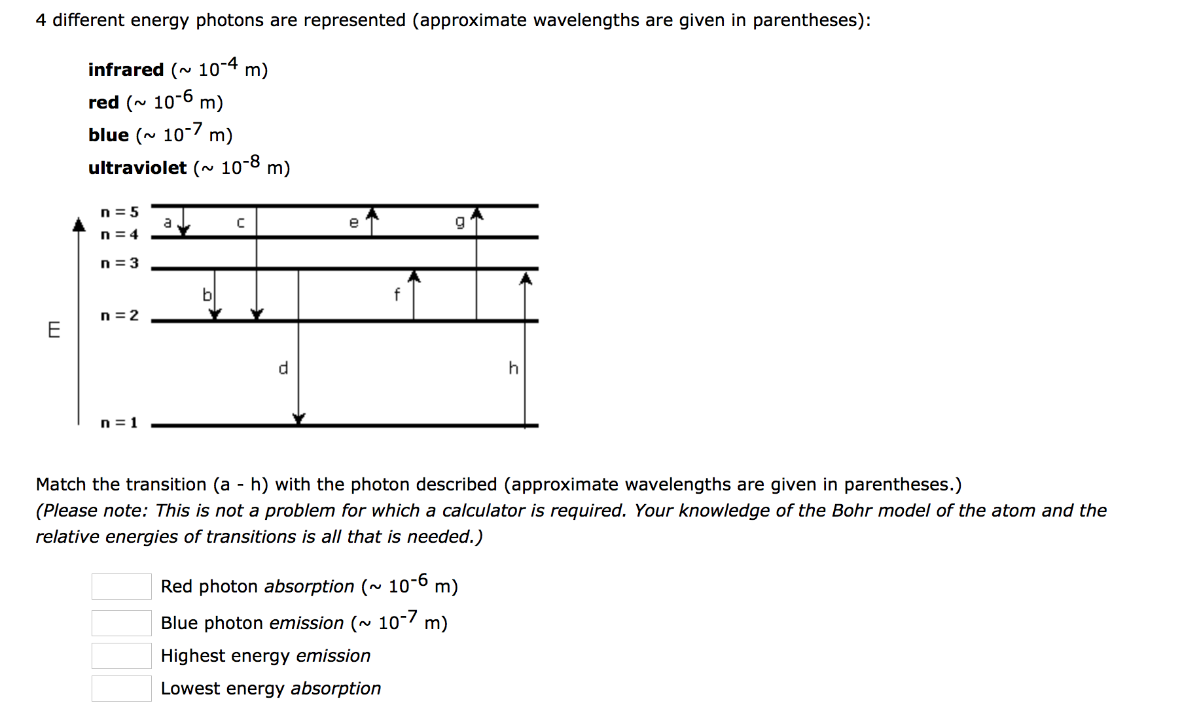

**Practice problems:**

1. Determine the frequency of light whose wavelength is 5.347 x 10-7 cm. What portion of the electromagnetic spectrum does this represent?
2. Determine the energy of a photon whose frequency is 5.33 x 1015 Hz
3. Cobalt-60 is an artificial radioisotope that is produced in a nuclear reactor and used as a gamma ray source in the treatment of certain types of cancer. If the wavelength of the gamma radiation from a cobalt-60 sourceis 1.00 x 10-3 nm, calculate the energy of a photon of this radiation.
4. If a photon has a frequency of 7.600 x 1012 Hz what is its wavelength?

**TLDR 4.2 The Quantum Model of the Atom (pp. 104-110)**

Like photons, electrons also exhibit wave-particle duality. That is, in some cases they behave like little bullets (particles) and in some cases they behave as waves. When we are dealing with electrons in orbitals around atomic nuclei we will treating elections as waves.

Even Bohr himself knew that his orbital explanation was not exactly right. Sure, it accurately predicted the emission spectra of all of the elements they tried it on, but it was based on a non-physical application of classical physics. Bohr was treating electrons as little orbiting particles.

Erwin Schroedinger applied his wave-mechanical equations to the situation in the late 1920’s and found that treating electrons like the standing waves that are set up in a trumpet or saxophone also resulted in the same quantization of electron energies that made Bohr’s model such a success. As an added bonus, Schroedinger’s equation didn’t suffer from the same non-physical flaws that Bohr’s did. Instead of imagining electrons orbiting the nucleus like little moons around a planet (particle-like), Schroedingers wave mechanics allow us to imagine the orbitals around an atom as standing waves of probability (wave-like) of finding up to two electrons around an atom. The solution to the Schroedinger wave equation is pretty far out of the realm of the scope of this class. However, it turns out that when you solve the Schroedinger wave equation for electrons in “orbit” around an atom you get very specific types of standing waves, and three quantum numbers which describe these orbitals.

**Quantum numbers and their approximate interpretations**

1. The **principal quantum number (n)**

Can take integer values **from 0🡪∞**

* This quantum number tells us something about the **relative energy of electrons** and the **approximate distance** from the nucleus that they may be found

1. The **angular momentum quantum number (*l*)**

Can take integer values **from 0 🡪 (n-1)**

* This quantum number tells us something about the shape of the orbital
* If *l* = 0 ; the orbital is **s, or spherical**
* If *l* = 1; the orbital is in **a p sublevel** (dumbbell-shaped)
* If *l* = 2; the orbital is in **a d sublevel** (four-leaf clover-shaped)
* If *l* = 3; the orbital is in **an f sublevel** (f-orbital shaped) ☹

1. The **magnetic quantum number (ml)**

Can take integer values from -*l* 🡪 +*l*

* This quantum number tells us something about the orientation in space of each orbital in a sublevel (what direction it is pointing)
* If l= 0, then ml  can only be 0, meaning there is only 1 orbital in an s sublevel
* If l = 1, then ml can be -1,0,or 1, meaning there are 3 orbitals in a p sublevel
* If l = 2, then ml can be -2,-1,0,+1,+2, meaning there are 5 orbitals in a d sublevel
* If l = 3, then ml can be -3,-2,-1,0,+1,+2,+3, meaning there are 7 orbitals in an f sublevel

1. The **spin quantum number (ms)**

Can take one of two values either -1/2 or +1/2.

The chart below summarizes the range of possible quantum numbers available for elements in the first 4 periods on the periodic table. Notice that the 1st p subleveli occurs in the 2nd principal energy level (2p) and the first d sublevel occurs in the 3rd principal energy level.

|  |  |  |  |  |  |  |
| --- | --- | --- | --- | --- | --- | --- |
| **Principal Quantum #**  **(n)** | **Angular momentum**  **(l)** | **Magnetic Quantum #**  **(ml)** | **Spin Quantum #**  **(ms)** | **Type of sublevel** | **# of orbitals** | **# of electrons** |
| **1** | 0 | 0 | +1/2,-1/2 | s | 1 | 2 |
| **2** | 0  1 | 0  -1, 0, +1 | +1/2,-1/2  (+1/2,-1/2)x3 | S  p | 1  3 | 2  6 |
| **3** | 0  1  2 | 0  -1, 0, +1  -2,-1,0,+1,+2 | +1/2,-1/2  (+1/2,-1/2)x3  (+1/2,-1/2)x5 | s  p  d | 1  3  5 | 2  6  10 |
| **4** | 0  1  2  3 | 0  -1, 0, +1  -2,-1,0,+1,+2  -3,-2,-1,0,1,2,3 | +1/2,-1/2  (+1/2,-1/2)x3  (+1/2,-1/2)x5  (+1/2,-1/2)x7 | s  p  d  f | 1  3  5  7 | 2  6  10  14 |

**TLDR 4.3 Electron Configurations (pp. 111-122)**

Assigning electrons to orbitals in atoms requires the application of 3 rules:

1. **The Aufbau Rule-** Electrons fill lowest energy orbitals first.

* If you use the “order of orbital filling” chart on the back of your periodic table, you are following the Aufbau rule.

1. **The Pauli Exclusion Principle**- One set of 4 quantum numbers can only describe the location of 1 electron.

* Orbitals can hold up to 2 electrons max.

1. **Hund’s Rule** (the “ski-trip” rule)-when multiple orbitals are ***degenerate*** (meaning: they have the same energy) electrons will occupy each orbital singly before pairing.

* Electrons only pair with other electrons if there is no alternative.

Electron configurations are a short-hand method of indicating the relative position and energy of electrons in atom. They always include a principal energy level (number) followed by a letter designating the type of sublevel the electrons are in (s, p, d, f) and finally a superscript number indicating the number of electrons that inhabit that sublevel.

**Example problem:**

Write the complete electron configurations for K, Sr, C and S. Then write the short-hand electron configuration using noble gas configuration for each.

K = 1s22s22p63s23p64s1

Sr= 1s22s22p63s23p64s23d104p65s2

C= 1s22s22p2

S= 1s22s22p63s23p4

*notice that the sum of the superscripts for each electron configuration is equal to the atomic number for that element.

K = [Ar] 4s1

Sr= [Kr]5s2

C= [He]2s22p2

S= [Ne]3s23p4

**Practice problems:**

1. Write the ground-state electron configurations for the following elements, indicate how many unpaired electrons there are in each. How many valence electrons are there in each element.

Mg, N, Ne,Se,C,O

1. Write the electron configurations for the following ions

Mg2+, O2-, Cl-, K+

1. Draw a picture of that compares the following
   1. The size and shape of a 1s orbital and a 3s orbital
   2. The size and shape of the2px orbital and the 3px orbital
   3. The relative orientations of the 3 p orbitals in the 3rd principal energy level.