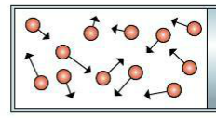
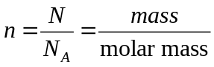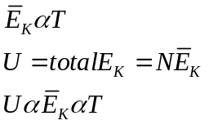
Absolute Uncertainty Δx = 0.2 cm
Fractional Uncertainty Δx/x = 0.2 cm / 4.4 cm

Measurement with absolute uncertainty:
x ± Δx = 4.4 ± 0.2 cm

Measurement with percentage uncertainty:
4.4 ± 5%
Percentage Uncertainty Δx/x ∙ 100% = 0.2 cm / 4.4 cm x 100% = 0.045 = 4.5% = 5%

1. Addition/Subtraction Rule: When two or more quantities are added or subtracted, the overall uncertainty is equal to the sum of the absolute uncertainties.
2. Multiplication/Division Rule: When two or more quantities are multiplied or divided, the overall uncertainty is equal to the sum of the percentage uncertainties.
3. Power Rule: When the calculation involves raising to a power, multiply the percentage uncertainty by the power.

Graph straightening by logs
Take log of both sides
Log y = n log x + log c
Power Function:
y = c·x^{n}
slope = n
y-intercept = log c
or c = 10^{b}

N = total number of particles (atoms or molecules)
N_{A} = 6.02 x 10²³ particles/mole (Avogadro’s constant)
n = number of moles
The internal energy (U) of an ideal gas consists solely of kinetic energy (no potential energy since no bonds) and is proportional to absolute temperature.
Where k_{B}=
Boltzmann’s constant
1.38 x 10⁻²³ J/K
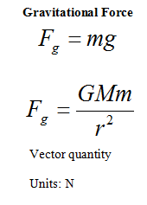
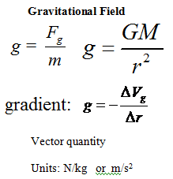
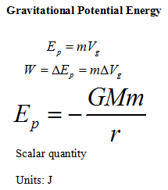
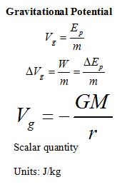
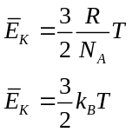
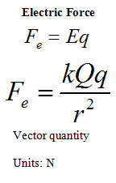
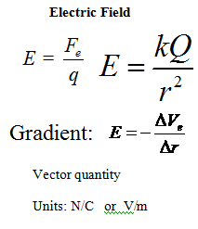
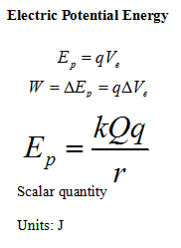
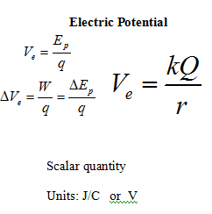
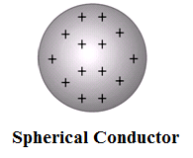
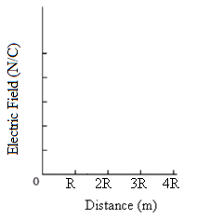
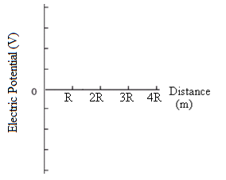

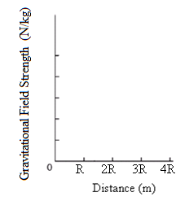
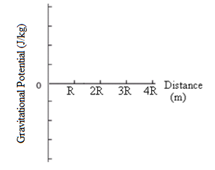

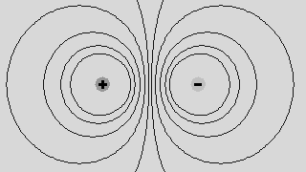
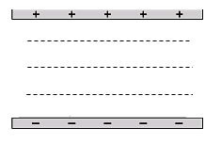
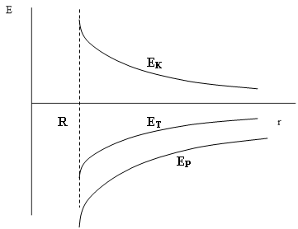
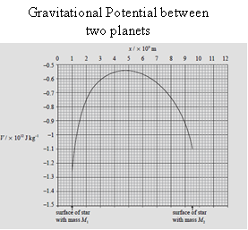
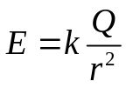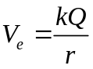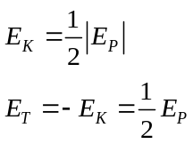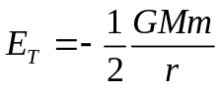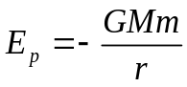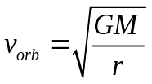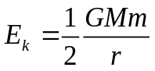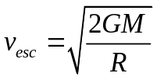
Inside: E = 0, V = constant
Outside:
Like equal charges
Opposite equal charges
Equipotential surfaces are always perpendicular to field lines.
Two equal masses
Two parallel plates
Satellites
Energies of Orbiting Satellite
Orbital Speed
Escape Speed
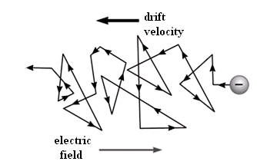
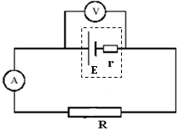
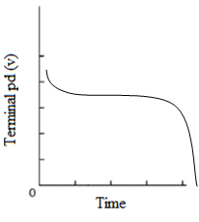
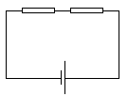
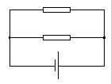
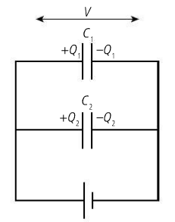
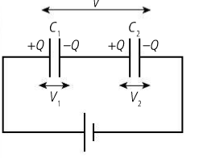
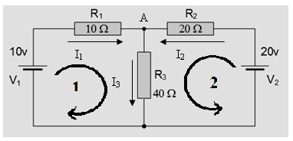
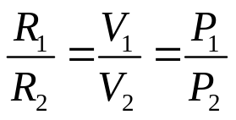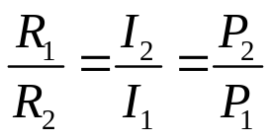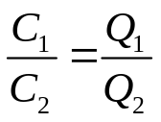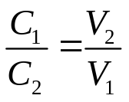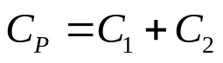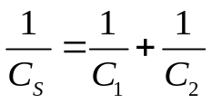
Drift Velocity (v) Formula:

I = nAvq
Where n = charge density (number of charges per unit volume

A = cross-sectional area

For a cell/battery with internal resistance:
r = internal resistance
R = total external resistance
ε, E = emf
V = terminal potential difference (Vterm)
ε = I (R + r)
ε = IR + Ir
ε = V_{term} + Ir

Characteristics of how the terminal p.d. of a cell varies with time
Control:
V₁ = V₂
Series Resistors
Parallel Resistors
Control:
V₁ = V₂
Parallel Capacitors
Control:
Series Capacitors
Q₁ = Q₂
Control:
I₁ = I₂
Equivalent capacitance
Equivalent capacitance
Kirchhoff’s Loop Rule (ΣV = 0): Around any closed loop in a circuit, the sum of the EMFs equals the sum of the potential differences. (total voltage rises = total voltage drops)
Kirchhoff’s Junction Rule (ΣI = 0): At any junction in a circuit, the sum of the currents entering the junction equals the sum of the currents leaving the junction. (total current in = total current out)
Solve Three Simultaneous Equations
ΣI = 0 at A:
I₁ + I₂ = I₃
ΣV = 0 for Loop 1:
10 = 10I₁ + 40I₃
ΣV = 0 for Loop 2:
20 = 20I₂ + 40I₃
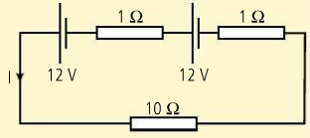
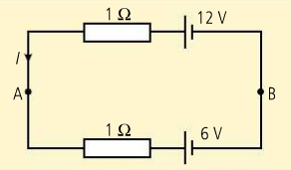
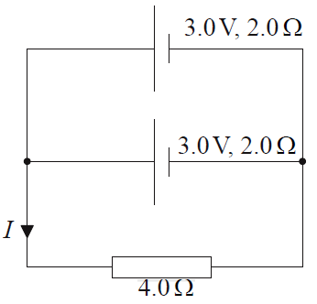
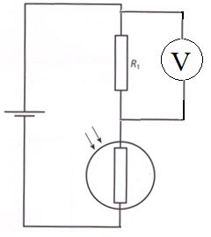
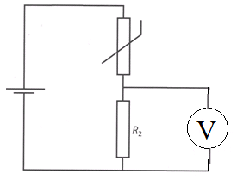
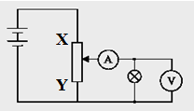
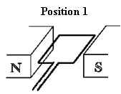
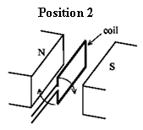
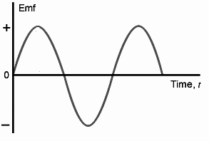
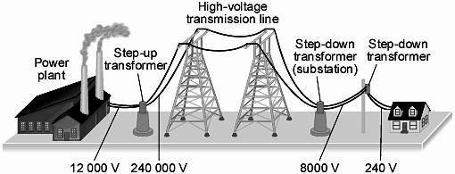
I. Emfs in series in the same direction: add the voltages
II. Emfs in series in opposite directions: subtract the voltages
III. EMFs in parallel: same EMF but add internal resistances
Light-Dependent Resistor (LDR) or Light Sensor: A photo-conductive cell made of semiconducting material. When light strikes it, charge carriers are released. As more light strikes it, more charge carriers are released and thus its resistance goes down.
Relationship: as intensity of light increases, resistance decreases
Negative Temperature Coefficient (NTC) Thermistor or Temperature Sensor: A sensor made of semiconducting material, also known as a thermistor (thermal resistor). As the thermistor gets hotter, more charge carriers are released and thus its resistance goes down.
Relationship: as temperature increases, resistance decreases.
Measuring I-V Characteristics
With a potentiometer
As the slider moves from X to Y, current through lamp and potential difference across it decreases (ammeter and voltmeter decrease.)

When the plane of coil is parallel to magnetic field lines . . .

flux = 0, ΔΦ/Δt = max,
ε = max, I = max
When the plane of coil is perpendicular to magnetic field lines . . .

flux = max, ΔΦ/Δt = 0, ε = 0, I = 0
Generator: Alternating Current and EMF
Spinning coil twice as fast will:

a) double maximum emf

b) double the frequency

c) halve the period
Power Transmission: First, step-up transformers to increase voltage and decrease current. This reduces power loss (I⁻²R loss) as heating in the power lines. Then step-down transformers to reduce voltage and increase current at houses.
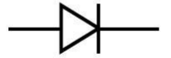
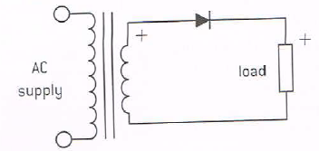
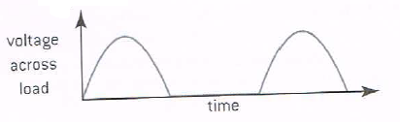
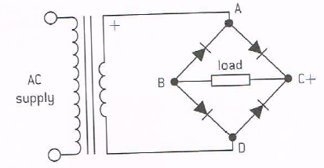
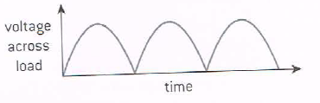
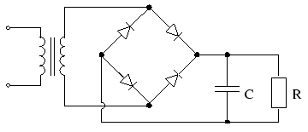
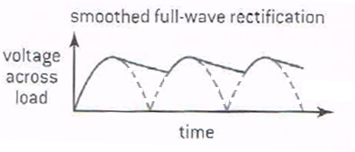
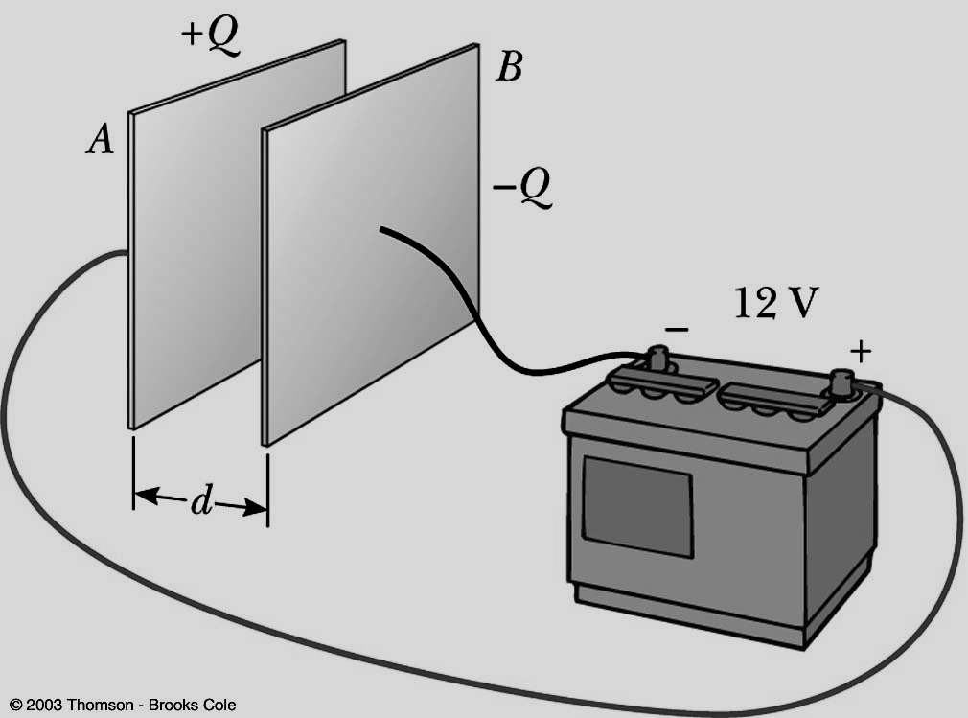
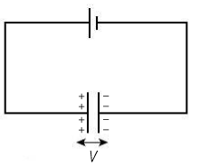
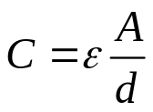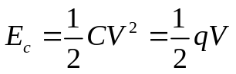
Rectification: the process of converting an AC supply into DC (uses diodes)
Diode: a semiconductor device that only allows current to flow in one direction
a) Half-wave rectification: uses one diode - allows only the positive half of the AC wave to pass
Circuit
Voltage output
b) Full-wave rectification: uses a diode bridge (with four diodes) – allows both halves of the AC wave to pass but the negative half is inverted
Circuit
Voltage output
- Diode bridge is formed from two sets of parallel diodes. Diodes on parallel sides of the bridge point in the same directions.
- During each half-cycle of AC, one set of parallel-side diodes conducts.
- Output current always flows through the load resistor in the same direction (DC).
- The output voltage and current are not constant or smooth. A capacitor may be used to “smooth” the output (see below).
Capacitor: a device that stores charge and energy
Capacitance: the ratio of charge to potential difference
Formula: C = q/V
General Formula:
Dielectric material: an electrical insulator that is polarized when placed in an electric field
Energy stored in a capacitor:
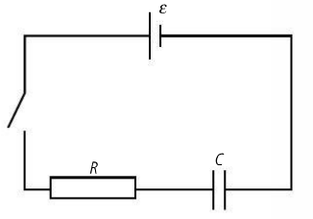
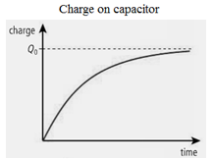
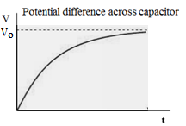
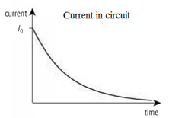
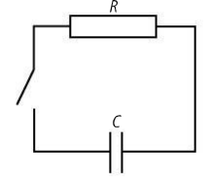
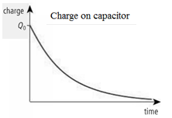
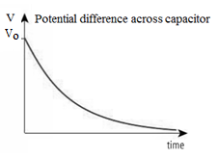
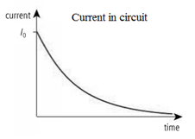
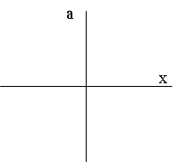
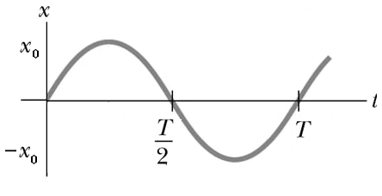
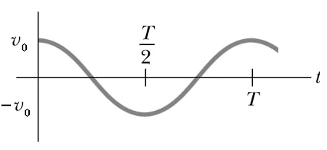
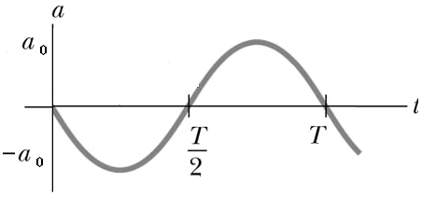
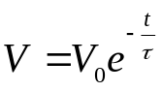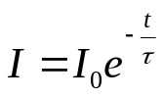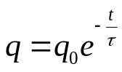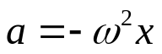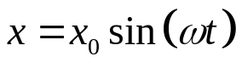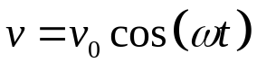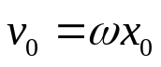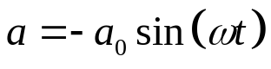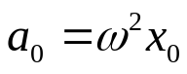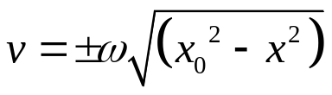
Charging a Capacitor
Discharging a Capacitor
Time constant: τ = RC
Simple Harmonic Motion (SHM) – motion that takes place when the acceleration (or restoring force) of an object is proportional to its displacement from its equilibrium position and is always directed toward its equilibrium position
Defining Equation for SHM:
Where
ω = angular frequency
ω = 2π/T = 2 πf
a) Displacement Function
b) Velocity Function
Maximum displacement: x_{o}
c) Acceleration Function
Maximum velocity:
Maximum acceleration:
Alternate Velocity Function
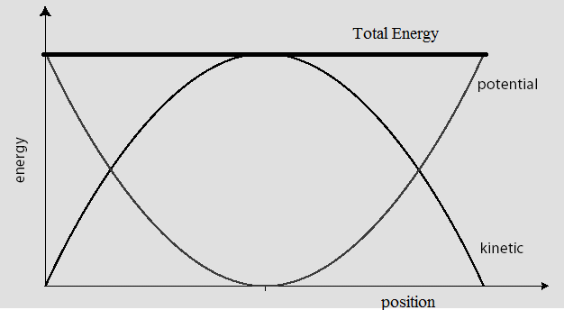
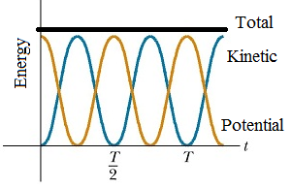
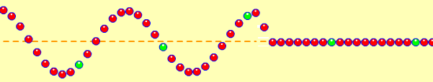
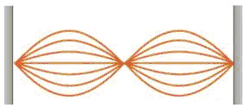
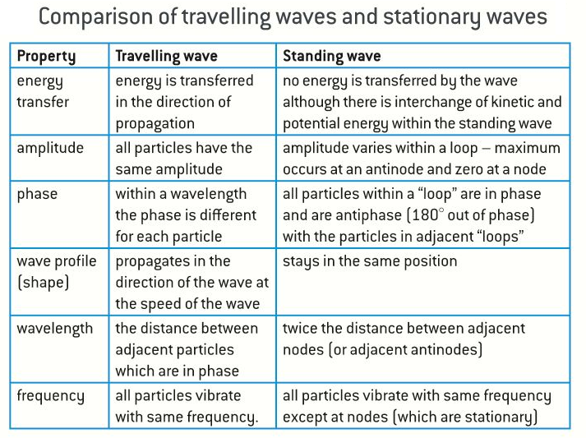
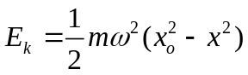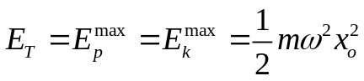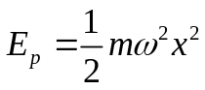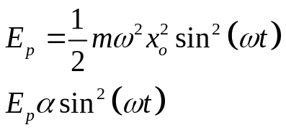
Standing Wave
Energies as functions of position
Energies as functions of time
Traveling Wave
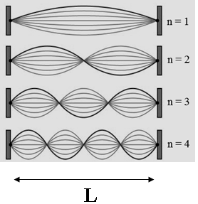
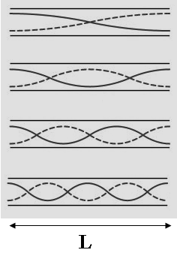
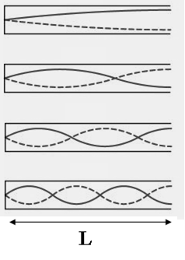
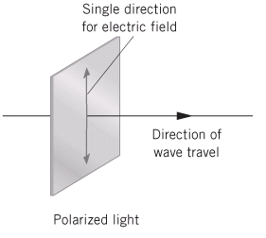
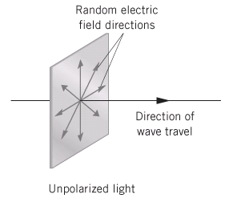
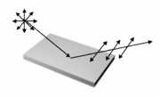
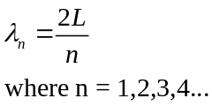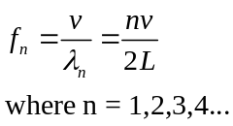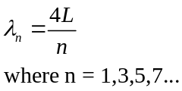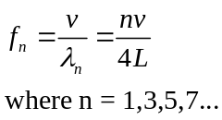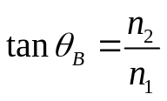
I. Transverse Standing Wave: string fixed at both ends
II. Longitudinal Standing Wave: pipe open at both ends
III. Longitudinal Standing Wave: pipe open at only one end
First Harmonic (fundamental):
L = ½ λ
First Harmonic (fundamental):
L = ½ λ
First Harmonic (fundamental):
L = ¼ λ
(no even harmonics)
 | Boundary conditions | First Harmonic  (fundamental) | Resonant Wavelengths  (higher harmonics) | Resonant Frequencies  (higher harmonics)
String of length L | Both ends fixed or both ends free | L = ½ λ₁  λ₁ = 2L
Pipe of length L | Both ends open or both ends closed | L = ½ λ₁  λ₁ = 2L
String of length L | One end fixed, the other end free | L = ¼ λ₁  λ₁ = 4L
Pipe of length L | One end open, the other end closed | L = ¼ λ₁  λ₁ = 4L

Polarized Light – light in which the electric field vector vibrates in one plane only.
Unpolarized Light – light in which the electric field vector vibrates in random directions.
Glare: Reflected light that is polarized parallel to surface (horizontal)
Polarization by reflection from a non-metallic plane surface
At one particular angle called the polarizing angle (or Brewster’s angle), the reflected ray would be completely polarized. At this angle, the reflected ray and the refracted ray are at right angles.
Brewster’s Angle (θ_{B}):
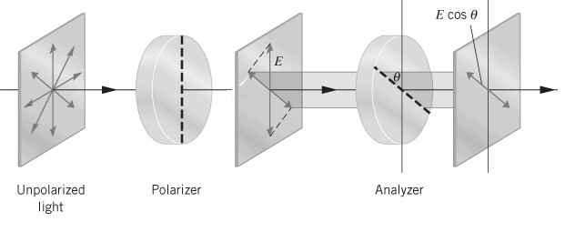
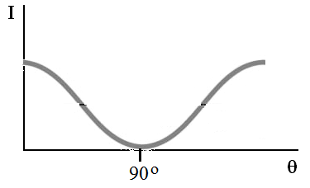
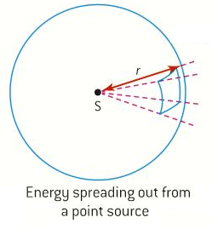
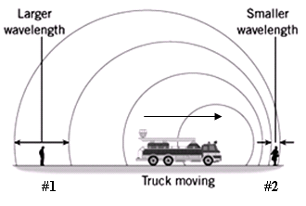
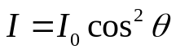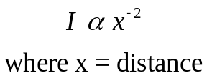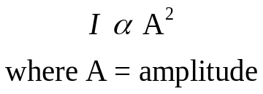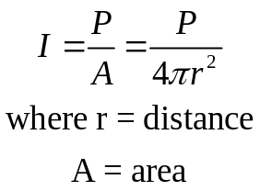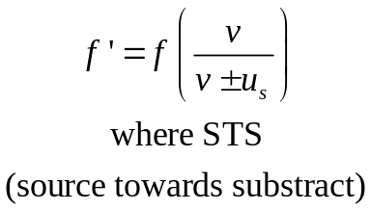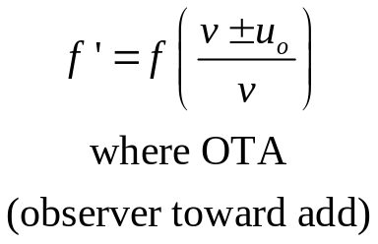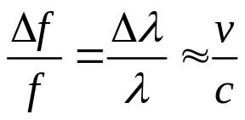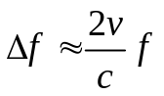
Malus’ Law:

Where:
I = transmitted intensity
I₀ = intensity of light incident on the analyzer (second film)
θ = angle between transmission axis of polarizer (first film) and analyzer
50% of unpolarized light passes through any polarizing film
Intensity: power per unit area
As the distance from the source doubles . . . ¼ I

Intensity (and energy) is proportional to the square of the amplitude of a mechanical wave
Doppler Effect for Sound
Moving Source
Moving Observer
Doppler Effect for Light (all EM waves, including RADIO WAVES)
Approximation is only valid for speeds much less than the speed of light.
When both source and observer are moving, double the frequency shift.
Path Difference (Δℓ) – difference in the distances two waves must travel from their sources to a given point (e.g. - 1λ, ½ λ, …)
Phase Difference – difference in the phases of the two waves when they overlap (e.g. – 0, 180º)
Constructive Interference - Phase difference: 0 Path difference: Δℓ = n λ where n = 0, 1, 2, 3, …
Destructive Interference - Phase difference: 180⁰ (π) Path difference: Δℓ = (n + ½ ) λ where n = 0, 1, 2, 3, …
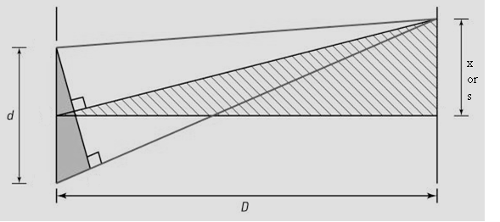
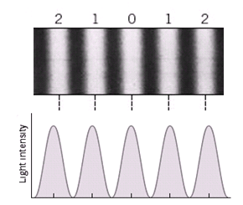
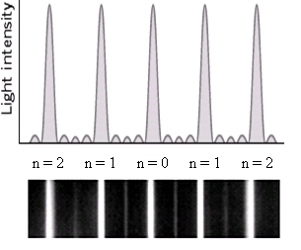
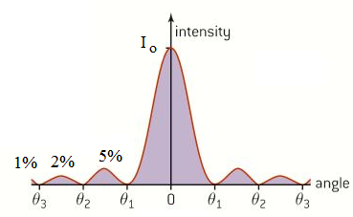

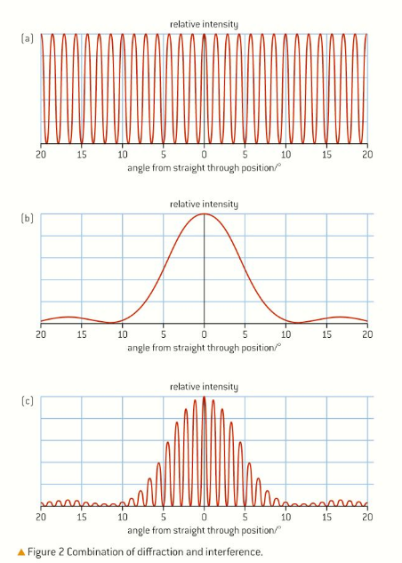
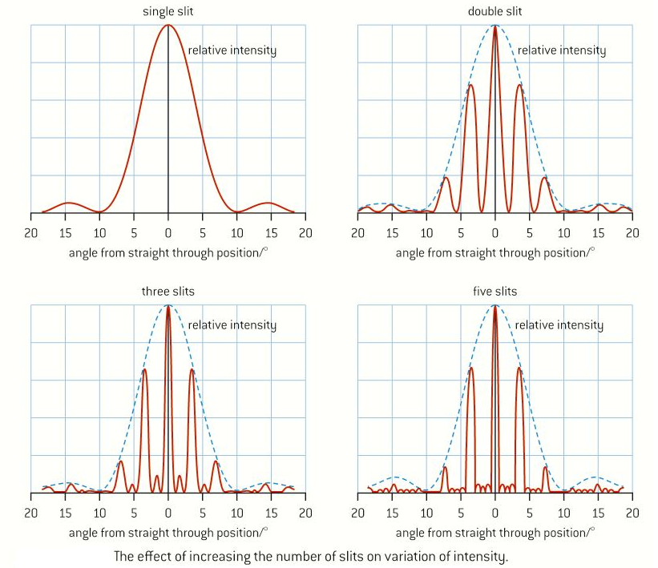
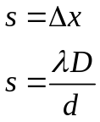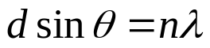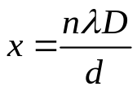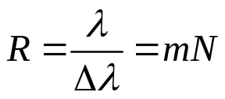
Angular displacement from the central maximum
Linear displacement from the central maximum
Fringe separation
Double Slit Interference Patterns
Ideal Intensity Distributions for Double Slit Interference Patterns
a) equal spacing and widths

b) equal brightness
Multiple Slit Interference (Diffraction Grating)
As the number of slits increases . .
a) maxima maintain location but become narrower and more intense
b) minima are not totally dark

Single Slit Intensity Pattern

a) Wide bright central maximum
b) Equal and dim secondary maxima
c) White light – white central max, rainbow secondary max
Modulation of double-slit interference pattern by single-slit diffraction effect
Comparison of intensity patterns showing the effect of increasing the number of slits on intensity
Resolvance (R) of a diffraction grating: the ratio between a wavelength being investigated (λ ) and the smallest possible resolvable wavelength difference (Δλ)
R = resolvance

m = 1,2,3… (order)

N = total # of slits
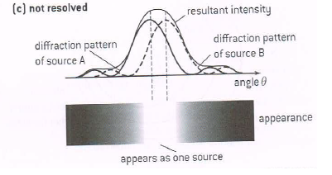
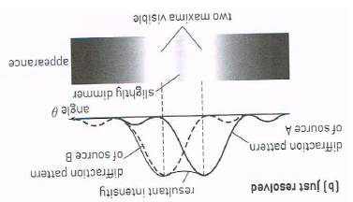
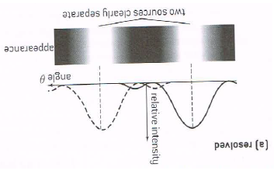
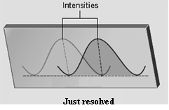
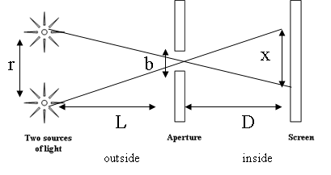
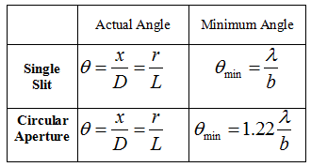
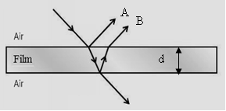
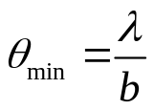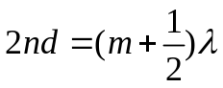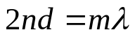
Resolution (resolving power): the ability to distinguish between two sources of light
Rayleigh Criterion: For two sources to be “just resolved,” the central maximum of one diffraction pattern is located on top of the first minimum of the other diffraction pattern.
The minimum angle (θ_{min}) between the sources for them to be “just resolved” is the angular half-width of one diffraction pattern.
For two light sources to be resolved, check if the actual angle between them is greater than the minimum angle.
Thin Film Interference
Where:
m = 0,1,2…
n= index of refraction
d = thickness of film
Constructive interference of rays A and B will occur if the two rays are in phase.
Destructive interference of rays A and B will occur if the two rays are 180º out of phase.
NOTE: The above two formulas are derived for the case where the two rays undergo only one hard reflection. In the case where the light rays undergo two hard reflections (or two soft reflections) then…switch the formulas.
If the light ray reflects from a substance with a higher index of refraction, the phase difference is 180º (λ/2) = hard reflection.
If the light ray reflects from a substance with a lower index of refraction, the phase difference is 0º = soft reflection.
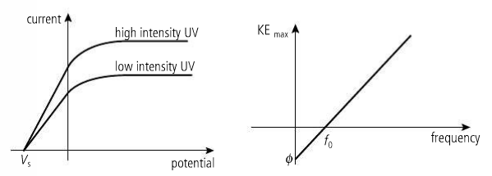
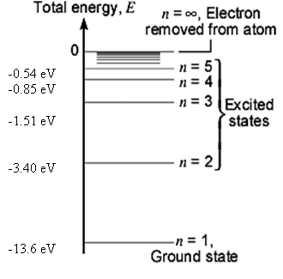
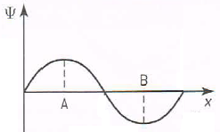
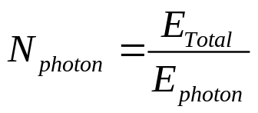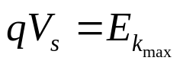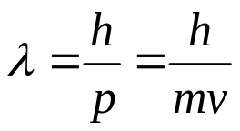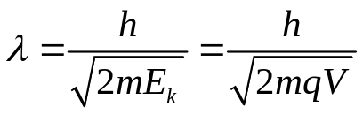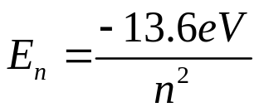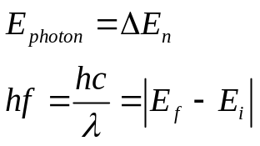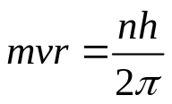
When light shines from a given source (flashlight, laser, etc.): | Energy of each photon | Total energy | Number of photons
If the frequency of the light is constant, as the intensity of the light increases…. | remains the same | increases | increases
If the intensity of the light is constant, as the frequency of the light increases…. | increases | remains the same | decreases

Stopping Potential (V_{s}): minimum potential difference that stops all photoelectric current

Maximum kinetic energy of ejected electrons (E_{max}):
Photoelectric Effect
De Broglie wavelength
De Broglie Hypothesis: All particles can behave like waves whose wavelength is given by λ = h/p where h is Planck’s constant and p is the momentum of the particle.

De Broglie wavelength after accelerating through a potential difference V
Hydrogen Spectrum: atomic energy levels can be calculated from
The energy of a photon emitted or absorbed can be calculated from:
The angular momentum of an electron in a stationary state is quantized in integral values of h/(2π).

When electrons go up levels, they absorb photons.

When electrons drop levels, they emit photons.
Square of the amplitude of the electron’s wave function is … proportional to probability of finding the electron at a particular location.
Wave function (ψ): An equation associated with the electron (or, a property of the electron) that may be used to calculate the probability of finding the electron at a particular location.
Particle is most likely to be found at A and B where amplitude is greatest.
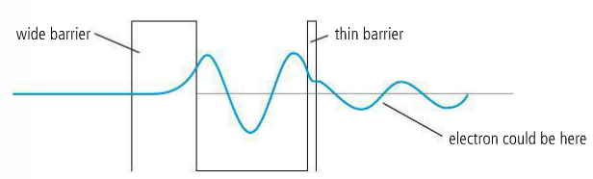
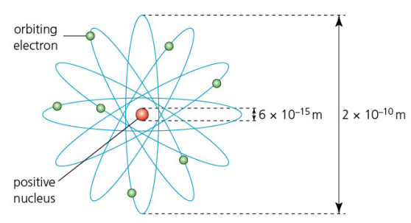
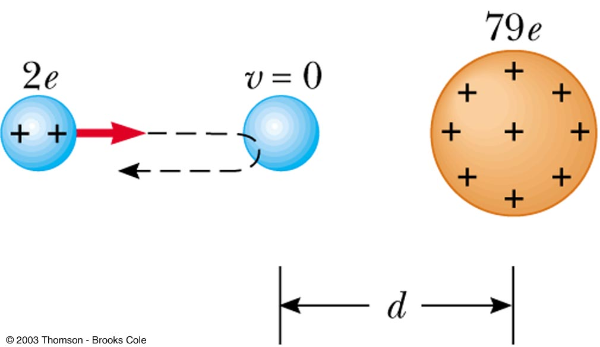
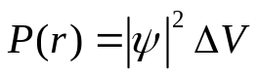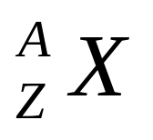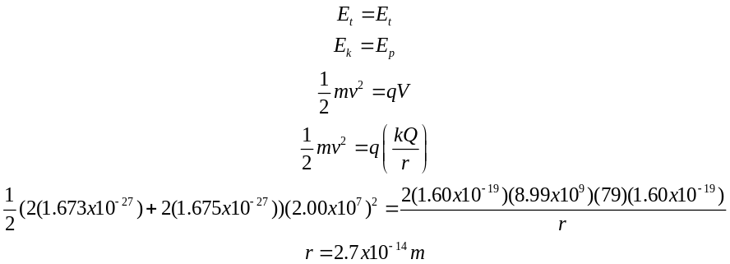
A nitrogen atom
Probability Density Function:
Where P (r) = probability of finding particle at distance r

|ψ|² = square of amplitude of wave function

ΔV = small volume
Implications
- The more you know about one of the conjugate quantities, the less you know about the other.
- If one of the conjugate quantities is known precisely, all knowledge of the other is lost.
Uncertainty Principle
- Both the position and momentum of a particle cannot be precisely known at the same time.
- Both the energy state of a particle and the amount of time it is in that energy state cannot be precisely known at the same time.
conjugate quantities: position and momentum or energy and time

Δx ∙ Δp ≥ h/4π
ΔE ∙ Δt ≥ h/4π
Quantum Tunnelling: a quantum mechanical phenomenon in which a particle passes through a barrier that it would not be expected to pass through using only the laws of classical physics
Factors that affect tunnelling probability:
a) thickness of the barrier
b) mass of the particle
c) difference in energy between the particle and the height of the potential barrier
Nuclide: a particular type of nucleus

Nucleon: a proton or a neutron
Atomic number (Z) (proton number): number of protons in nucleus

Mass number (A) (nucleon number): number of protons + neutrons

Neutron number: number of neutrons in nucleus (A – Z)

Isotopes: nuclei with same number of protons but different numbers of neutrons
Unified atomic mass unit (u): 1/12th the mass of a carbon-12 atom
- 1 u = 1.661 x 10⁻²⁷ kg
- 1 u = 931.5 MeV/c²
- 1 u = 1 g/mol

Size of atom: 10⁻¹⁰m
Size of nucleus: 10⁻¹⁵m – 10⁻¹⁴ m
Distance of Closest Approach
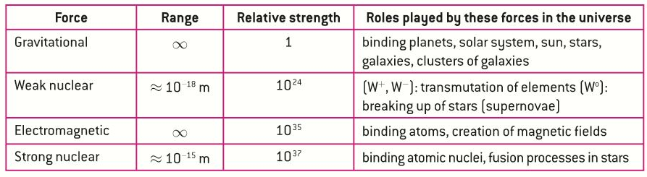
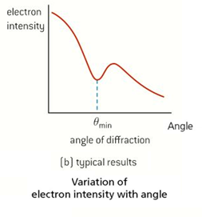
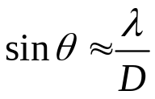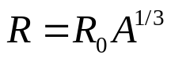
Fundamental Forces and their Properties
Deviations from Rutherford scattering: The scattering experiments performed by Rutherford, Geiger, and Marsden were limited by the energies of the alpha particles emitted by the radioactive sources available to them. When their experiments are repeated using more energetic alpha particles it is found that, at these higher energies, the Rutherford scattering relationship does not agree with experimental results. At higher energies the alpha particles were able to approach the target nucleus so closely that the strong nuclear attractive force overcomes the electrostatic repulsion. The method of closest approach gives an approximation of the size of a nucleus. More reliable values for the size of a nucleus can be from using electron diffraction experiments.
Where:

D = diameter of nucleus
Nuclear densities are approximately the same for all nuclei. The only macroscopic objects with the same density as nuclei are neutron stars.
Radius (R) of a Nucleus
Where:

A = mass number (number of nucleons)

R_{o} = Fermi radius (a constant)
Energy units | Mass units
MeV | MeV c⁻²
GeV | GeV c⁻²
eV | eV c⁻²

Nuclear binding energy (ΔE )

a) energy released when a nuclide is assembled from its individual components

b) energy required when nucleus is separated into its individual components

Mass defect (mass deficit) (Δm)

Difference between the mass of the nucleus and the sum of the masses of its individual nucleons

Formulas:
m_{nucleus} + Δm = m_{nucleons}
ΔE = Δ m c2
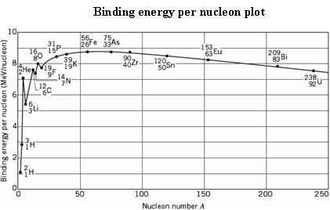
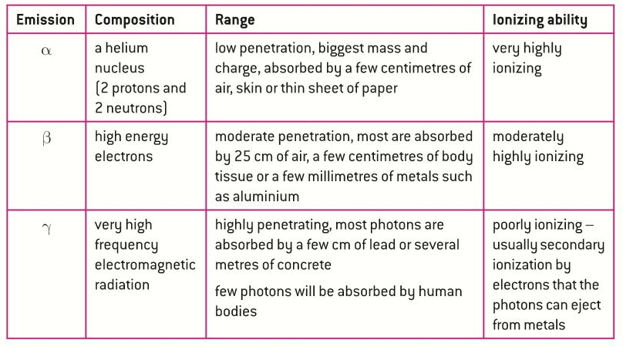
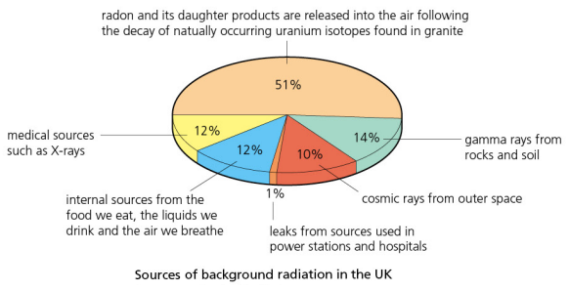
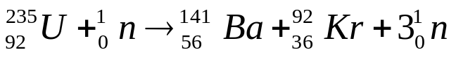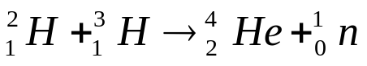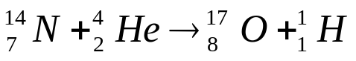
1. As a nucleus gains more nucleons,
- its total binding energy . . . increases
- while its binding energy per nucleon . . . increases then decreases

2. Most nuclei have a binding energy per nucleon . . . approximately 8 MeV, between 7 and 9

3. As the binding energy per nucleon increases, the nucleus . . .is in a lower energy state and is more stable

4. The most stable common nucleus is . . . Fe-56 (most stable is Ni-62)

Nuclear Fission: A heavy nucleus splits into two smaller nuclei of roughly equal mass with the release of energy.
Nuclear Fusion: Two light nuclei combine to form a more massive nucleus with the release of energy.
Fission/fusion reactions: m_{reactants} = m_{products} + Δm
Artificial (Induced) Transmutation: A nucleus is bombarded with a nucleon, an alpha particle or another small nucleus, resulting in a nuclide with a different proton number (a different element).
Artificial transmutation reactions: m_{reactants}+ Δm = m_{products}
1. Which type of radiation has the greatest penetrating ability? Why?
Gamma because it is a photon
(no mass, high energy, very fast)
2. Which type of radiation has the greatest ionizing ability? Why?
Alpha –does greatest damage due to high mass
Background Radiation: We are exposed to ionizing radiation all the time from naturally-occurring sources. This is called background radiation.
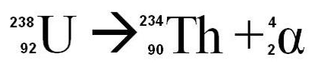
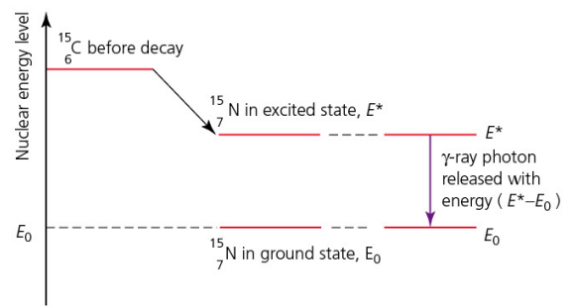
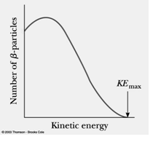
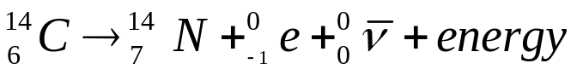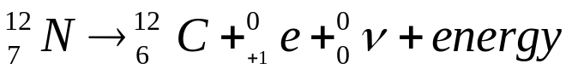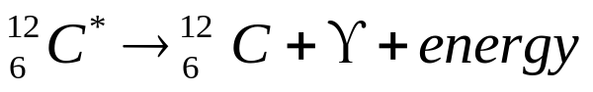
I. Alpha Decay
Alpha particle: helium nucleus, α, ₂⁴He
Radioactive decay reactions: m_{reactants} = m_{products} + Δm
II. Beta Decay
Beta-minus particle: electron, β⁻, ₋₁⁰e
Beta-plus particle: positron, β⁺, ₊₁⁰e
Gamma particle: high energy photon, γ
III. Gamma Decay
Rules for drawing nuclear energy level diagrams:
a) Alpha and beta decays are drawn to the side
b) Gamma decays are drawn vertically down
Which energy spectra are continuous and which are discrete? Alpha and gamma are discrete, beta is continuous
Which energy spectra give evidence for the quantization of nuclear energy levels? Alpha and gamma only
Why does the continuous spectrum of beta decay not show evidence for nuclear energy levels?
Since two particles are ejected, the KE can be split between them in any proportion so the spectrum is continuous and thus the quantization of the nuclear energy levels is not demonstrated.
Evidence for Atomic and Nuclear Structure
Atomic Feature | Evidence
Size of nuclei  (nuclear radii) | Measurements made from charged particle scattering experiments such as the Geiger-Marsden experiment (Rutherford alpha particle scattering experiment)
Nuclear masses | Measured using a Bainbridge mass spectrometer
Existence of isotopes | Evidence provided by the results of Bainbridge mass spectrometer measurements: two atoms of the same atomic number (same number of protons) land at a different spot and so have a different mass, therefore must have a different number of neutrons.
Atomic energy levels  (electrons energy levels) | Emission and absorption spectra  (line spectra)
Nuclear energy levels | Discrete energy spectra of alpha particles in alpha decay  Discrete energy spectra of gamma rays in gamma decay

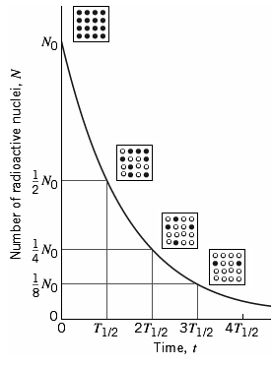
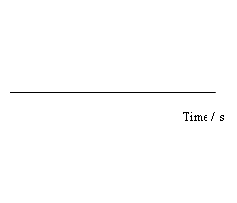
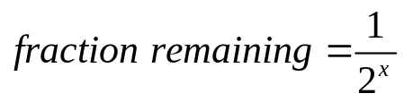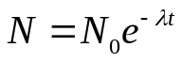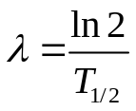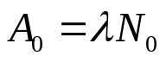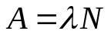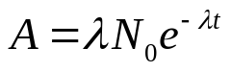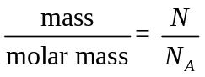
Radioactive decay:
- Random process: It cannot be predicted when a particular nucleus will decay, only the probability that it will decay.

- Spontaneous process: It is not affected by external conditions. For example, changing the pressure or temperature of a sample will not affect the decay process.

- Rate of decay decreases exponentially with time: Any amount of radioactive nuclei will reduce to half its initial amount in a constant time, independent of the initial amount.
Half-life (T_{1/2}): the time taken for ½ of the radioactive nuclides in a sample to decay

Where x = number of half-lives = time/T_{1/2}
N₀ = number of radioactive nuclei originally present

N = number of radioactive nuclei present at any one time
Activity (decay rate) (A) – the number of radioactive disintegrations per unit time [1 Becquerel (Bq) = 1 decay per second]

Decay constant (λ)
- constant of proportionality between the decay rate (activity) and the number of radioactive nuclei present.

- probability of decay of a particular nucleus per unit time.

A₀ = initial activity
ln(N₀)
Slope = -λ
ln(A₀)
Methods of Determining Half-life
If the half-life is short, then readings can be taken of activity versus time using a Geiger counter, for example. Then, either a graph of ln (activity) versus time would be linear and the decay constant can be calculated from the slope.
If the half-life is long, then the activity will be effectively constant over a period of time so a different method is required.
a) First, the activity (A) can be measured with a Geiger counter,

b) then the number of atoms might be determined chemically,

c) then the decay constant can be calculated

d) and thus the half-life can be calculated.
A = λN
T_{1/2} =ln 2/λ
Straightening by natural log
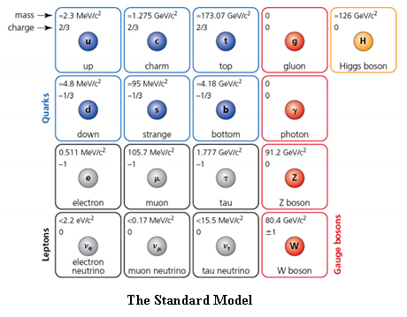
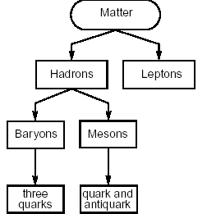
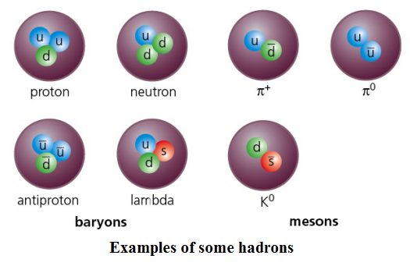
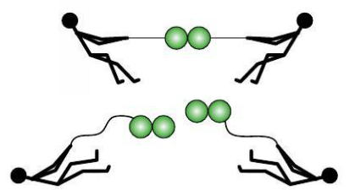
The Standard Model of particle physics is the theory that says all matter is composed of combinations of six types of quarks (and six antiquarks) and six types of leptons (and six antileptons), as well as four types of gauge bosons (exchange particles) that mediate the four fundamental forces, and the Higgs boson. This is the currently accepted theory. Each of these particles is considered to be fundamental (or elementary) which means that they have no internal structure, that is, that they are not made out of smaller constituents. Gravity is not explained by the Standard Model.
According to the Standard Model, all matter particles can be classified according to the scheme shown at right.
Quark Confinement – Isolated quarks cannot be observed. If sufficient energy is supplied to a hadron in an attempt to isolate a quark, the energy supplied will produce more hadrons or mesons rather than isolated quarks since the strength of the strong interaction increases with distance.
Higgs Boson - According to original versions of the Standard Model, quantum mechanical calculations predicted that quarks and leptons (as well as the W and Z bosons) should have no mass, but measurements showed that they did. One solution to this problem would be if mass was not a property of the particle itself but a property of space. This is known as the Higgs field and the particle associated with it is called the Higgs boson. A particle with properties matching that of the Higgs boson was detected at the LHC in 2012.
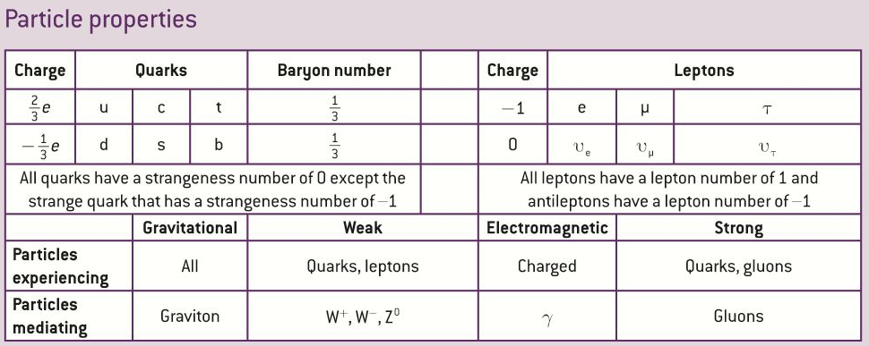
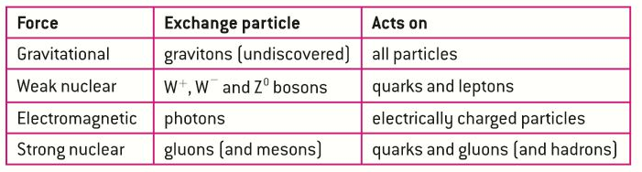
a) Electric Charge b) Baryon Number
NOTE: Antiparticles have same mass as corresponding particles but all quantum numbers are opposite.
Quantum Numbers - Every particle has certain properties that are assigned a number, such as:
c) Lepton Number d) Strangeness
NOTE: An antiparticle is usually denoted by a bar over the symbol. Three leptons are exceptions:
a) Electron (beta- particle): e⁻ and the antielectron (positron, beta+ particle): e⁺
b) Mu particle (mu lepton, muon): μ⁻ and the antimuon (positive muon): μ⁺
c) Tau particle (tau lepton, tauon): τ⁻ and the antitau (positive tau): τ⁺
The four fundamental forces/interactions from strongest to weakest: Strong, electromagnetic, weak, gravitational
“Exchange particles” or “gauge bosons”: Particles that “mediate” an interaction, that is, particles that are exchanged between two objects causing the appearance of a force occurring
The only interaction in which a quark (or lepton) can change into another quark (or lepton) is the weak interaction.
The interaction that involves neutrinos is the weak interaction.
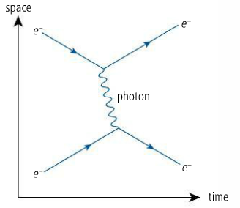
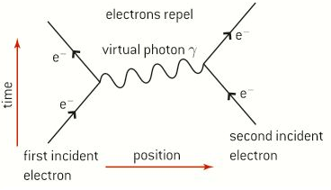
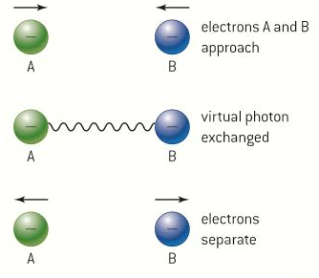
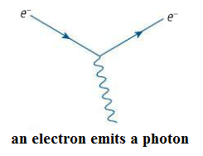
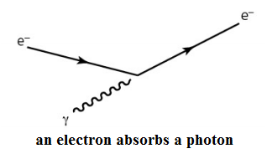
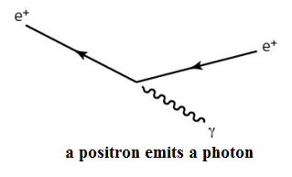
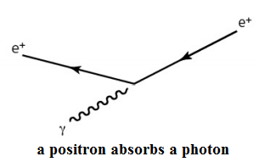
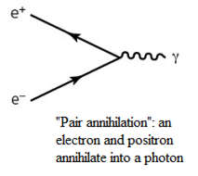
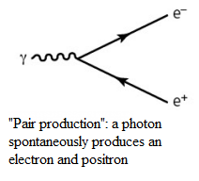
Rules for constructing Feynman diagrams
a) The x-axis represents time, going from left to right, and the y-axis represents space.
NOTE: Sometimes these two axes are reversed.

b) Quarks or leptons are shown by solid lines with arrows.

c) Exchange particles are shown either by wavy or broken lines (photons, W and Z bosons) or a curly lines (gluons).

d) Time flows from left to right. Arrows from left to right represent particles travelling forward in time. Arrows from right to left represent antiparticles travelling forward in time.

e) A junction or vertex (point where lines meet) is made up of two solid lines (two particles) and one wavy/dashed/curly line (exchange particle). Each vertex has one arrow going in and one arrow going out.

f) Vertices represent interactions so at each vertex all the conservation laws must apply.

Examples of Feynman Diagrams
1. Electromagnetic interaction between two electrons, shown using both possible sets of axes.
2.
3.
4.
5.
6.
7.
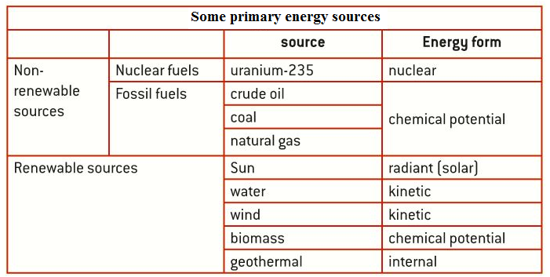
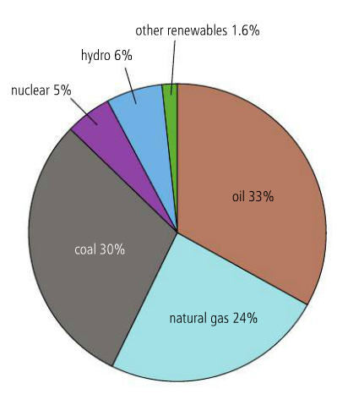
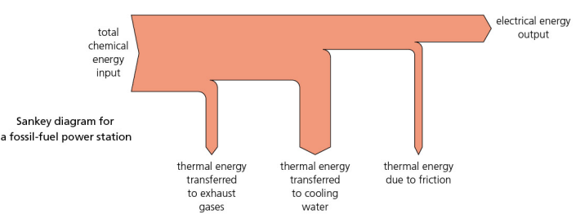
Fossil fuels: coal, oil, natural gas

Origins of fossil fuels: Organic matter decomposed under conditions of high temperature and pressure over millions of years.
Non-renewable fuels: The rate of production of the fuel is much smaller than rate of usage so fuel will run out (limited supply).
Renewable fuels: A resource that cannot be used up or is replaced at same rate as it is being used.
Primary energy source: one that has not been transformed or converted before use by the consumer
Secondary energy source: one that results from the transformation of a primary energy source
In many cases, these primary energy sources are converted into … electricity (secondary source)
World energy use
Specific Energy of a fuel:
energy released from the fuel per unit mass
Units: J/kg, MJ/kg
Formula: SE = E/m
Energy Density of a fuel:
energy released from the fuel per unit volume

Units: J/m³, MJ/m³
Formula: ED = E/V
Different fuels can be compared by analyzing the:
Degraded energy: In any process that involves energy transformations, degraded energy is energy that is transferred to the surroundings (thermal energy) and is no longer available to perform useful work.
Sankey diagrams (energy flow diagrams): used to keep track of energy transfers and transformations

a) Thickness of arrow is proportional to amount of energy.

b) Degraded energy points away from main flow of energy.

c) Total energy in = total energy out.
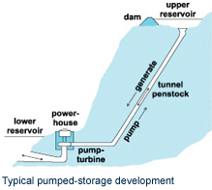
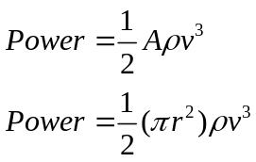
Nuclear Energy - Fission
Naturally Occurring Isotopes of Uranium:

- Uranium-238: most abundant (99.3%) but not used for fuel since it has a very small probability of fissioning when it captures a neutron.

- Uranium-235: rare (0.7%) but used for fuel since it has a much greater probability of fissioning when captures a neutron but must be a low-energy neutron (thermal neutron).
Fuel Enrichment: process of increasing the proportion of uranium-235 in a sample of uranium
Thermal Neutron: low-energy neutron (≈1eV) that favors fission reactions – its energy is comparable to gas particles at normal temperatures
How is the thermal energy that is released in the fission reactions used to generate electricity?

The coolant (which is often the same as the moderator) is fluid circulating around the fuel rods in the reactor core and is heated up by the thermal energy released in the fission chain reaction.
This coolant in a closed loop (primary loop) flows through pipes in a tank of water known as the “heat exchanger.” Here the thermal energy of the hot coolant is transferred to cooler water in a secondary loop which turns it to steam. This steam expands against fan blades of turbines and turns a magnet is a coil of wire to generate electricity.
Moderator: substance used to slow down neutrons to thermal levels to ensure that the fission takes place
Control Rods: used to remove neutrons to control the rate of the reaction
1. Solar heating panel (active solar heater): a panel containing pipes with a water-glycol mixture used to heat water (solar energy to thermal energy)

2. Photovoltaic cell (PV cell, solar cell): a cell of semi-conductive material used to generate electricity (solar energy to electrical energy) Operating Principle: photoelectric effect

Solar Power
Wind Power
Formula for Maximum Power from a Wind Generator
Hydroelectric Power
One method is called pumped storage. Water is pumped to a high reservoir during the night when the demand, and price, for electricity is low. During hours of peak demand, when the price of electricity is high, the stored water is released to produce electric power. A pumped storage hydroelectric power plant is a net consumer of energy but decreases the price of electricity. Energy stored in reservoir = E_{p} = mgh
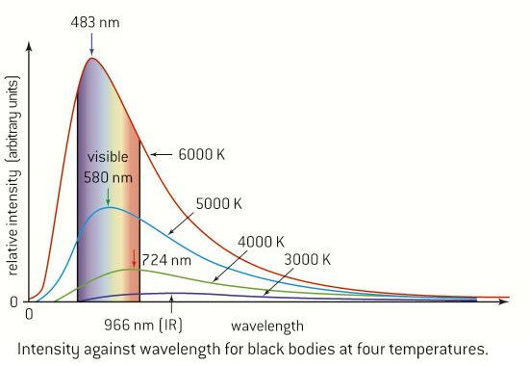
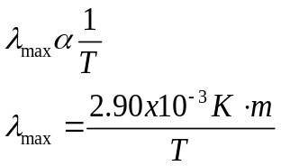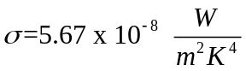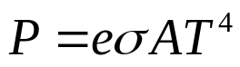
Principal Methods of Thermal Energy Transfer
II. Convection:
Convection is the bulk movement of groups of particles within fluids (liquids and gases) due to variations in density. Hotter less-dense fluid rises and cooler more-dense fluid falls to take its place. This is known as a convection current (cycle).

I. Thermal Conduction:
In conduction processes, energy flows through the bulk of the material without any large-scale relative movement of the particles (atoms/molecules) that make up the object. Faster moving particles collide with slower moving ones and transfer energy during the collisions. Conduction is primarily of importance in solids and less so in liquids and gases where the particles are further apart.
III. Radiation:
Thermal radiation is the transfer of energy by means of electromagnetic radiation. It has its origins in the thermal motion of the charged particles of the object that emit photons as they move and are accelerated. Radiation from the Sun reaches Earth across the vacuum of space.

 | Solids | Liquids | Gases
Conduction | X
Convection |  | X | X

An idealized physical body that absorbs all incident electromagnetic radiation, regardless of frequency or angle of incidence, is called a . . . black body

a) Not all wavelengths of light will be emitted with equal intensity.

b) Emitted wavelength with highest intensity (λ_{max} ) is related to . . . temperature.

c) Area under curve is proportional to . . . total power radiated by body

d) As body heats up, λ_{max} . . . decreases and total power . . . increases

Wien’s Displacement Law:
The wavelength at which the maximum power is emitted by a black-body is inversely proportional to its absolute temperature.
The Stefan-Boltzmann Law of Radiation:
The total power radiated by a black-body per unit area is proportional to the fourth power of the absolute temperature of the body.
Emissivity (e): the ratio of the power emitted by an object to the power emitted by a black-body of the same dimensions at the same temperature

Black-body:
e = 1
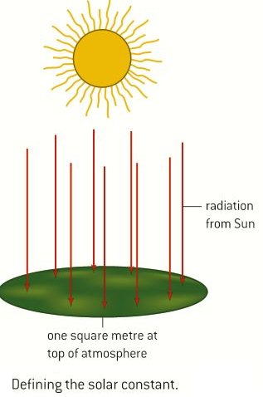
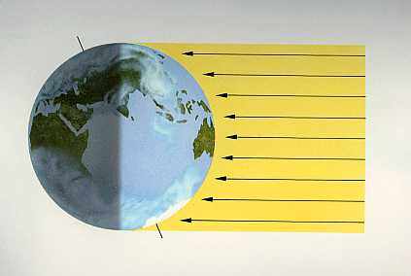
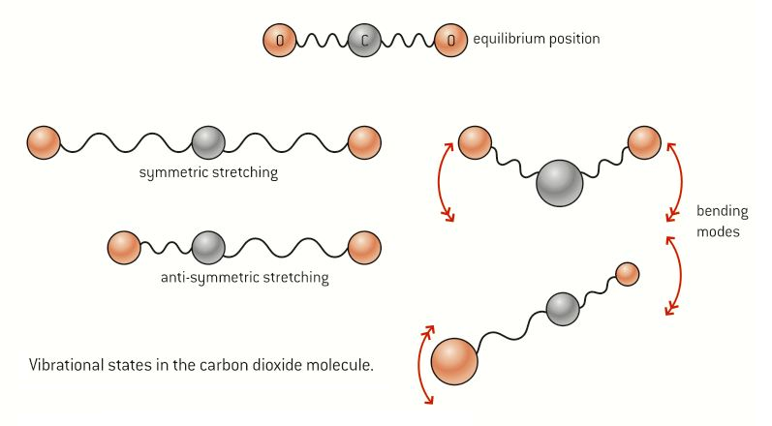
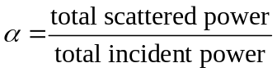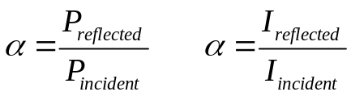
Solar constant
Meaning: The amount of energy from the Sun that arrives at the top of the atmosphere

Definition: The total radiation energy received from the Sun per unit of time per unit of area on a theoretical surface perpendicular to the Sun’s rays and at Earth’s mean distance from the Sun.
Value of solar constant: 1360 W/m²
Average value over entire surface of Earth: 340 W/m²
Meaning of albedo: the fraction of total incoming solar radiation that is reflected back out into space
Why does ice have the highest albedo? Most reflective

Global mean albedo? 30%

Albedo(α): ratio of total solar power scattered (reflected) to total solar power incident
Greenhouse Effect –

a) Short wavelength radiation (ultraviolet, visible, and short-wave infrared) received from the Sun causes the Earth’s surface to warm up.

b) Earth will then re-emit longer wavelength radiation (long-wave infrared) which is absorbed by some gases (greenhouse gases) in the atmosphere, due to resonance.

c) This energy is re-radiated in all directions (scattering). Some is sent out into space and some is sent back down to the ground and atmosphere.

d) The “extra” energy re-radiated causes additional warming of the Earth’s atmosphere and surface. This additional warming is known as the Greenhouse Effect.

Greenhouse Gases: each has natural and man-made origins
Water Vapor (H₂O) Carbon Dioxide (CO₂) Methane (CH₄) Nitrous Oxide (N₂O)
What is the molecular mechanism by which greenhouse gases absorb infrared radiation?
Resonance – The natural frequency of oscillation of the molecules of the greenhouse gases is in the infrared region (1 – 300 μm)

Enhanced Greenhouse Effect: increase in greenhouse gases in the atmosphere leads to absorption and re-radiation of extra solar energy leading to an increase in Earth’s surface temperatures (global warming)

