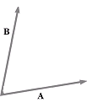
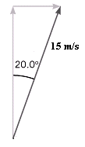
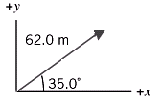
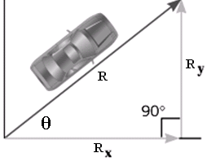
Kinematics – The Study of Motion
Symbols:
s =

u =
v =

a =
Equations:
Displacement - distance traveled from a fixed point in a particular direction

Velocity - rate of change of displacement

Speed - rate of change of distance

Acceleration - rate of change of velocity

average vs. instantaneous:
Condition for applying equations for uniformly accelerated motion:
1. Two friends bicycle 3.0 kilometers north and then turn to bike 4.0 kilometers west in 30. minutes.
a) What is their average speed?

b) What is their average velocity?

Mechanics
Scalars: quantities that have magnitude only

Vectors: quantities that have magnitude and direction
Notation: Bold italic F or arrow hat
e.g. - Mass, time, volume, energy, distance, speed
e.g. - Velocity, displacement, acceleration, force, momentum, impulse, magnetic field strength, gravitational field strength, electric field strength

Adding Vectors
Find the sum A + B
Subtracting Vectors
Find the difference A - B
1.

2.

Resolving a Vector into Its Components
Vector components:

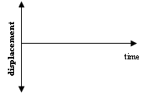
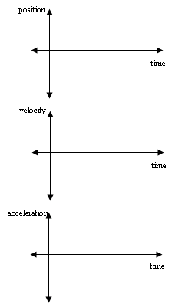
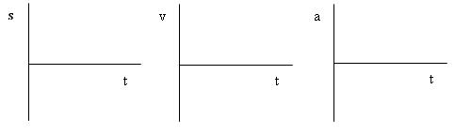
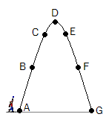

Constant Velocity
Constant (Uniform) Acceleration
2. The slope of a position-time graph is . . .

3. The slope of a velocity-time graph is . . .

4. The area under a velocity-time graph is. . .

Dropping
5. A stone is dropped from rest from the top of a tall building. After 3.00 s of free-fall, what is the displacement of the stone? What is its velocity?
How would these graphs change in the presence of air resistance?
Terminal velocity:
Throwing Up
A ball is thrown straight up in the air (shown here stretched out for clarity.) Sketch velocity and acceleration vectors at each instant.

6. To start a football game, a referee tosses a coin up with an initial speed of 6.00 m/s. In the absence of air resistance, how high does the coin go? How long is it in the air?

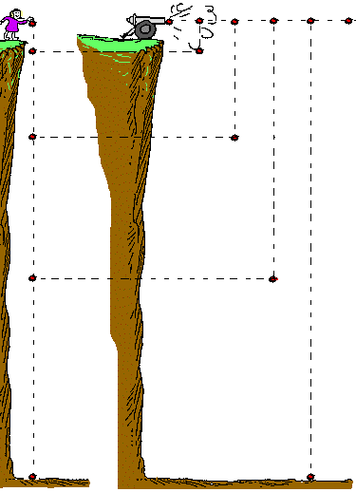
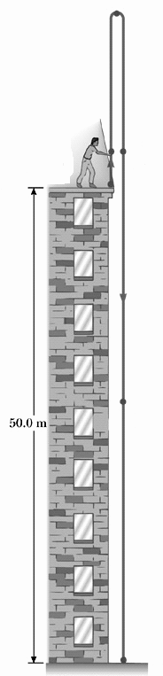

Projectile Motion:
Horizontal Projectile
8. A cannonball is shot horizontally off a cliff that is 100. m high at a speed of 25 m/s. How long does it take to hit the ground? How far away from the base of the cliff does it land?
Horizontal Component:
Vertical Component:
7. A stone is thrown straight up in the air with a speed of 20.0 m/s from the top of a building that is 50.0 m tall. The stone just misses the edge of the roof on the way down. How long will it take to hit the ground? How fast will it be going when it hits?
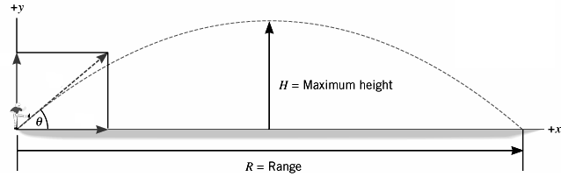
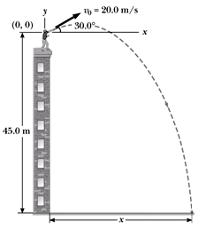

9. A football was kicked with a speed of 25 m/s at an angle of 30.0º to the horizontal. Determine how high it went and where it landed.
Angled Projectiles
effects of air resistance:
10. A stone is thrown upward from the top of a building at an angle of 30.0⁰ to the horizontal and with an initial speed of 20.0 m/s. The height of the building is 45.0 m.

- How long will it take the stone to hit the ground?
- How far away will it land?
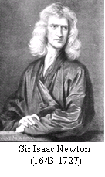
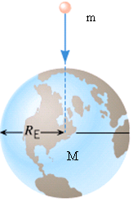
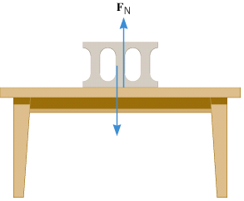
Newton’s First Law: An object at rest remains at rest and an object in motion remains in motion at a constant speed in a straight line (constant velocity) unless acted on by unbalanced forces. (An object continues in uniform motion in a straight line or at rest unless a resultant (net) external force acts on it.)
Statics and Dynamics – The Study of Forces
2nd Law or 3rd Law?
Net force on ball:
Action-Reaction pairs:

Net force on block:
Action-Reaction pairs:

Newton’s Second Law: When unbalanced forces act on an object, the object will accelerate in the direction of the resultant (net) force. The acceleration will be directly proportional to the net force and inversely proportional to the object’s mass. (The resultant force on an object is equal to the rate of change of momentum of the object.)
Newton’s Third Law: For every action on one object, there is an equal and opposite reaction on another object. (When two bodies A and B interact, the force that A exerts on B is equal and opposite to the force that B exerts on A.)
Formulas:
Action-Reaction pairs:
F_{g}
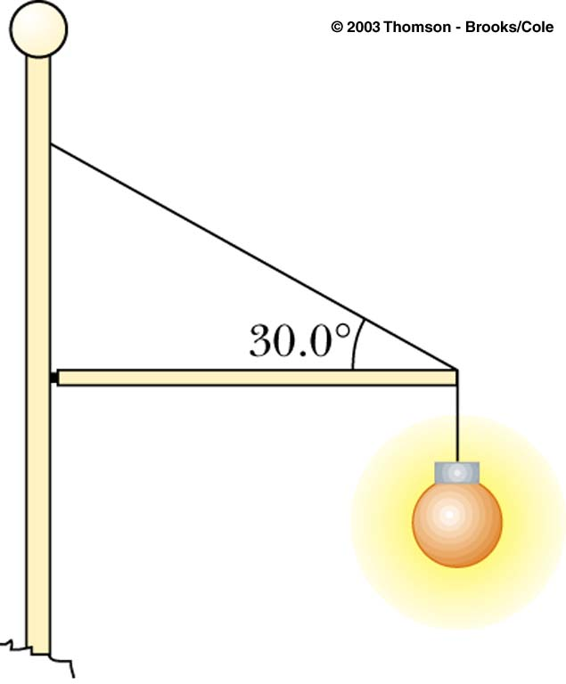

Translational equilibrium:
1. Find the resistive force F caused by the drag of the water on the boat moving at a constant velocity in the diagram shown.
2. A 20.0-kg floodlight in a park is supported at the end of a horizontal beam of negligible mass that is hinged to a pole, as shown. A cable at an angle of 30.0° with the beam helps to support the light. Find the tension in the cable.
3. Determine the tension in the string and the acceleration of each of the two objects connected by a light string over a light, frictionless pulley, as shown in the diagram.
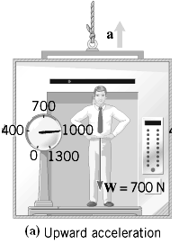
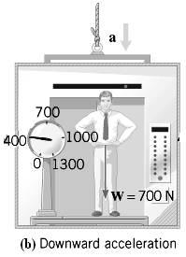

Weight, Mass, and the Normal Force
Mass
1) the amount of matter in an object
2) the property of an object that determines its resistance to a change in its motion (a measure of the amount of inertia of an object)

Property:
Remains constant

Symbol : m Units : kg

Weight:
the force of gravity acting on an object

Property:
Varies from place to place
Symbol : F_{g} or W

Units : N

Elevators: In each case, the scale will read . . .
1. Calculate the acceleration of the man in each case.
Inclined Plane

Free-body diagram
3. Calculate the force of friction acting on the box if it accelerates down the incline at a rate of 0.67 m/s².
Always:

If in equilibrium:

2. Calculate all the forces acting on this 8.0 kg box sliding at a constant speed of 12 m/s down a hill inclined at 25⁰ to the horizontal.
θ
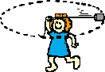
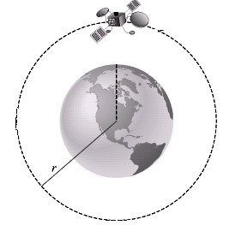
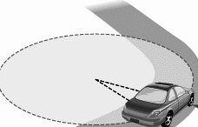
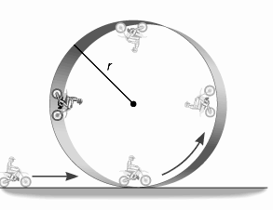
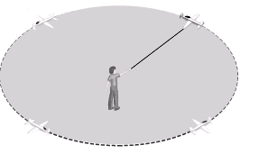
Symbol : F_{g} or W

Units : N

Uniform Circular Motion
Period: time take for one complete cycle symbol: T
Uniform Circular Motion
- The direction of the object’s instantaneous velocity is always . . .

- Since the direction of the object’s motion is always changing . . .

- Direction of net force –

- Centripetal force –

- Formulas:
1. A boy flies a 0.750-kg motorized plane on a 2.3 m string in a circular path. The plane goes around 8.0 times in 12.0 seconds. Determine the following:
b) the speed of the plane
c) the acceleration of the plane
d) the tension in the string
a) the period of revolution

5. At amusement parks, there is a popular ride where the floor of a rotating cylindrical room falls away, leaving the backs of the riders “plastered” against the wall. For a particular ride with a radius of 8.0 m and a top speed of 21 m/s, calculate the reaction force and the friction force from the wall acting on a 60. kg rider. Which of these is the centripetal force?
2. A 2100-kg demolition ball swings at the end of a 15-m cable on the arc of a vertical circle. At the lowest point of the swing, the ball is moving at a speed of 7.6 m/s. Determine the net force on the ball and the tension in the cable.
3. A 2000. kg car attempts to turn a corner going at a speed of 25 m/s. The radius of the turn is 15 meters. How much friction is needed to negotiate this turn successfully?
4. What is the speed of the Moon in orbit?
Type:
Scalar

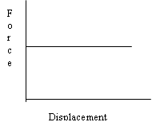
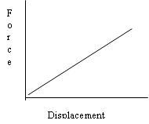
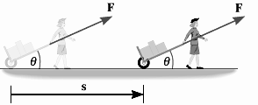
Determining Work Done Graphically:

1. Work done by a constant force
2. Work done by a constantly varying force
Example:
Work, Power and Energy
Work: product of force and displacement in the direction of the force
Type:

Formula:

Units:

- Positive Work: b) Negative Work: c) No Work:

Power:
1) the rate at which work is done

2) the rate at which energy is transferred
Formula:

Units:

Alternate Formula:

Efficiency: ratio of useful work done (or energy or power output) by a system to the total work done by (or energy or power input to) the system

Formula:

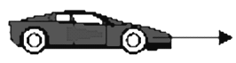

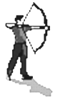
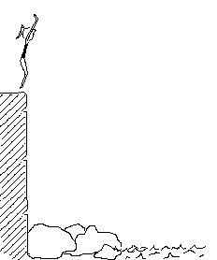
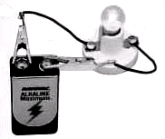
30⁰
20 meters
160 N

Energy
1.
2.
3.
4.
5.
Types of Energy
1. Kinetic energy (energy of motion)

2. Gravitational Potential energy (energy of position)

3. Elastic potential energy

4. Internal energy (thermal energy)

5. Electrical energy

Formulas:
1.

2.

3.

4.

5.
Conservation of Energy Principle
1. A stone is thrown upward from the top of a building at an angle of 30.0⁰ to the horizontal and with an initial speed of 20.0 m/s. The height of the building is 45.0 m. How fast is it going when it hits the ground?
2. What is the speed of the box at the bottom of the incline if an average frictional force of 15 N acts on it as it slides?
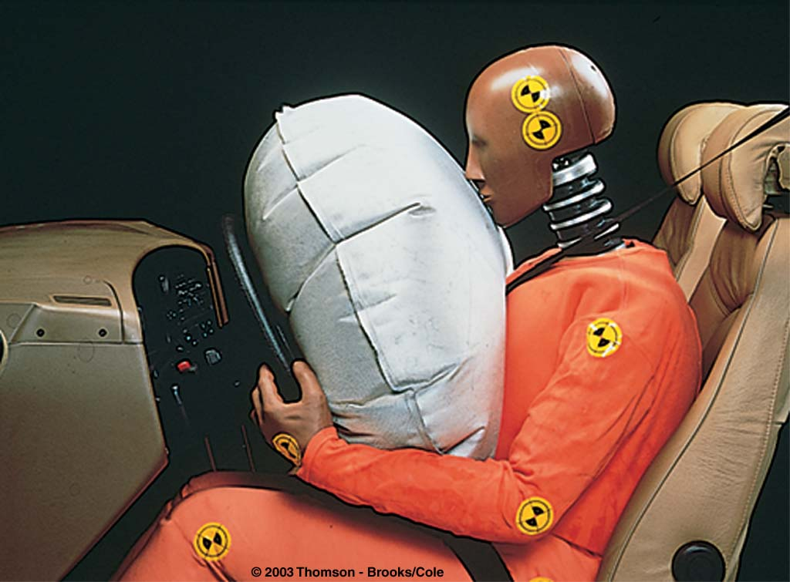
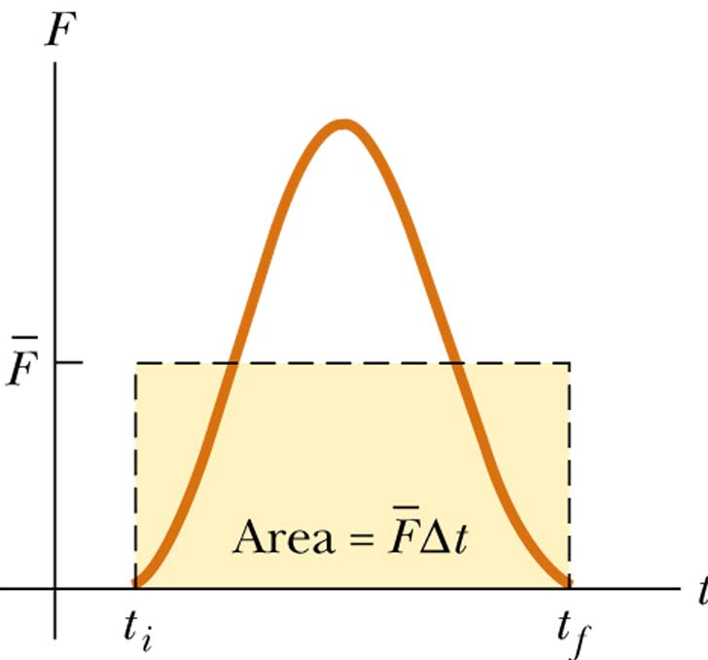
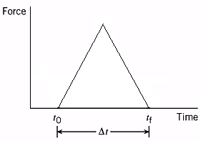
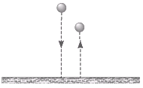
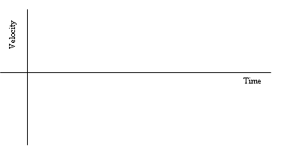
Units:
Joules (J)

Linear Momentum and Impulse
Linear Momentum: the product of an object’s mass and velocity
Formula:

Units:

Alternate formula for kinetic energy:
Impulse:

- the change in momentum of a system

- the product of the average force and the time interval over which the force acts
Impulse Formula
If the force is linear:

A 0.50 kg basketball hits the floor at a speed of 4.0 m/s and rebounds at 3.0 m/s. Calculate the impulse applied to it by the floor.
In general:
Calculation:
Velocity vs. time graph for bounce
Determining Impulse Graphically:

Type:

vector
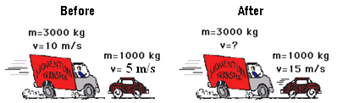
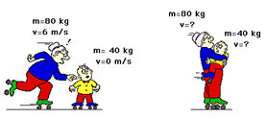
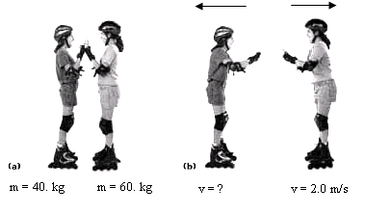
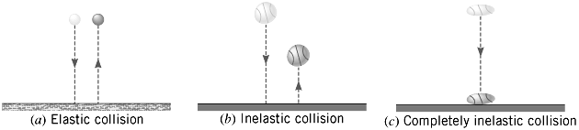
The Principle of Conservation of Linear Momentum:
Types of Interactions
1. Bouncy
2. Sticky
3. Explosion
Elastic collision:

Inelastic collision:

Where does some of the mechanical energy go in an inelastic collision?
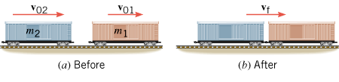
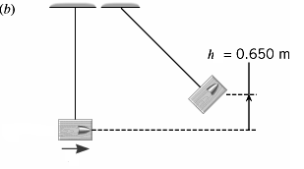
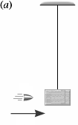

1. A freight train is being assembled in a switching yard, and the figure below shows two boxcars. Car 1 has a mass of 65,000 kg and moves at a velocity of 0.80 m/s. Car 2, with a mass of 92,000 kg and a velocity of 1.3 m/s, overtakes car 1 and couples to it. Neglecting friction, find the common velocity of the cars after they become coupled.
2. Is this collision elastic or inelastic? Justify your answer.
3. A ballistic pendulum is sometimes used in laboratories to measure the speed of a projectile, such as a bullet. A ballistic pendulum consists of a block of wood (mass = 2.50 kg) suspended by a wire of negligible mass. A bullet (mass = 0.0100 kg) is fired with an initial speed. Just after the bullet collides with it, the block (with the bullet in it) has a speed and then swings to a maximum height of 0.650 m above the initial position. Find the initial speed of the bullet, assuming that air resistance is negligible.

