
Discuss some of the possible problems that can occur as a result of peer pressure.
Peer pressure is not always a bad thing. Discuss some of the possible benefits that can occur as a result of peer positive pressure.

Read the poem aloud to your group. Discuss what it means.

“Any day of the week
I would choose to be “out” with others
And in touch with myself…
Than to be “in” with others
And out of touch with myself.”

- Portia Nelson

Read the quote aloud to your group. Discuss what it means.

“Two roads diverged in a wood, and I –
I took the one less traveled by,
And that has made all the difference.”

- Robert Frost

Put First Things First – The 7 Habits of Highly Effective Teens
Put First Things First – The 7 Habits of Highly Effective Teens

Put First Things First – The 7 Habits of Highly Effective Teens
– The 7 Habits of Highly Effective Teens
Put First Things First – The 7 Habits of Highly Effective Teens

Look at the time quadrants listed below. As a group, take turns discussing which quadrant best describes you. Explain why.
Why do you think the author used the following illustration with two circles when discussing courage and comfort zones?
Read the quote aloud to your group. Discuss what it means.

“Our doubts are traitors,
and make us lose the good we oft might win
by fearing to attempt.”

- William Shakespeare

Read the quote aloud to your group. Discuss what it means.

“It’s not the mountain we conquer,
but ourselves.”

- Edmund Hilary
(First person to climb Mt. Everest)

Put First Things First – The 7 Habits of Highly Effective Teens
Put First Things First – The 7 Habits of Highly Effective Teens

Put First Things First – The 7 Habits of Highly Effective Teens
– The 7 Habits of Highly Effective Teens
Put First Things First – The 7 Habits of Highly Effective Teens

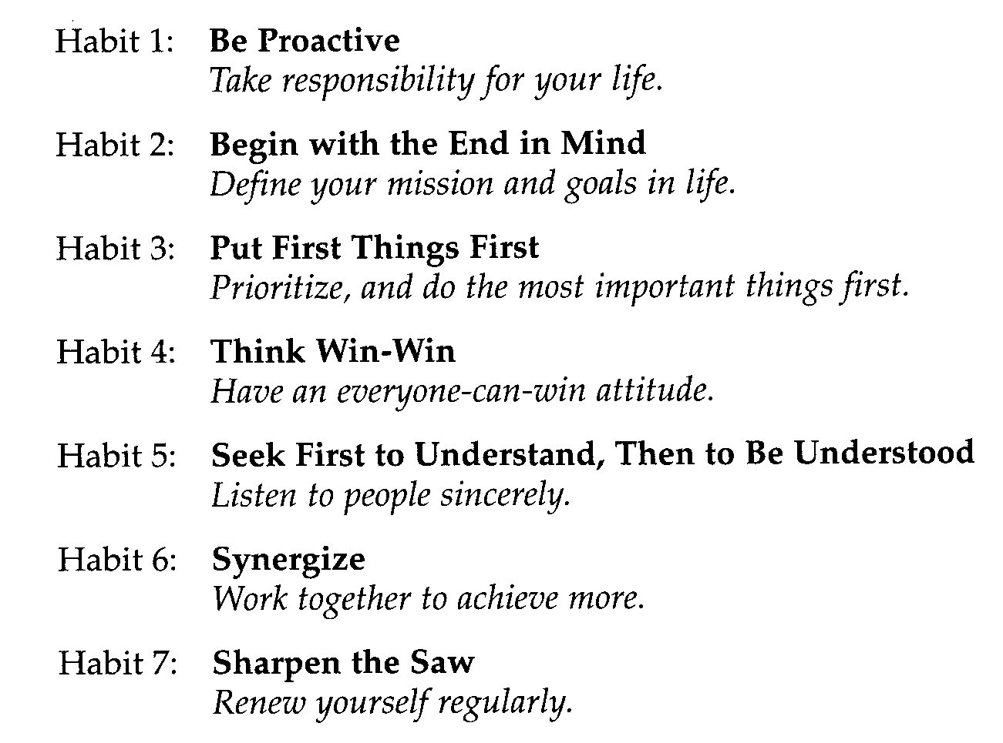
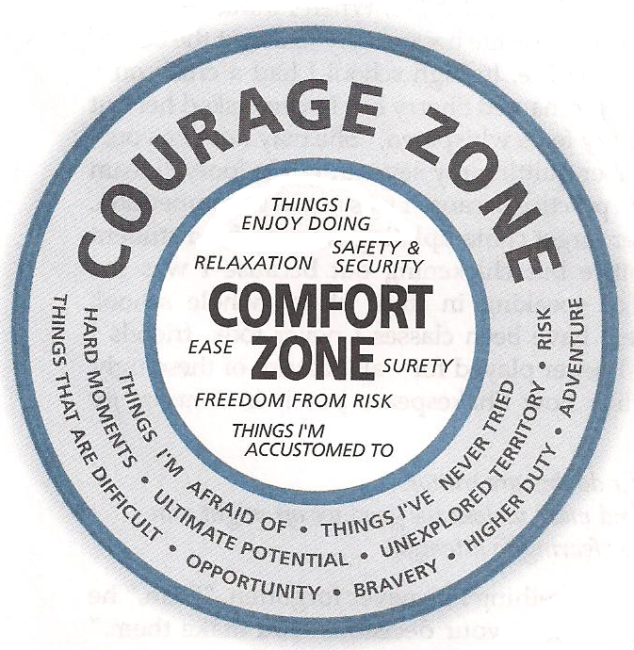
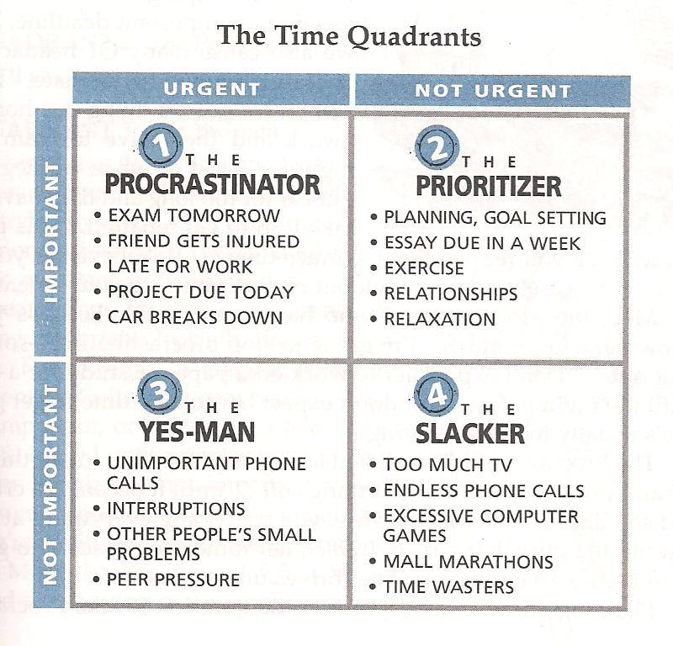
Think of a time when you acted in the face of fear and took a risk to move outside of your comfort zone. What did you learn?
Under what circumstances do you need to step outside of your comfort zone and exercise more courage?

How can you act more courageously?
What holds you back from moving into your courage zone?

Put First Things First – The 7 Habits of Highly Effective Teens

Put First Things First – The 7 Habits of Highly Effective Teens

Put First Things First – The 7 Habits of Highly Effective Teens

Put First Things First – The 7 Habits of Highly Effective Teens

