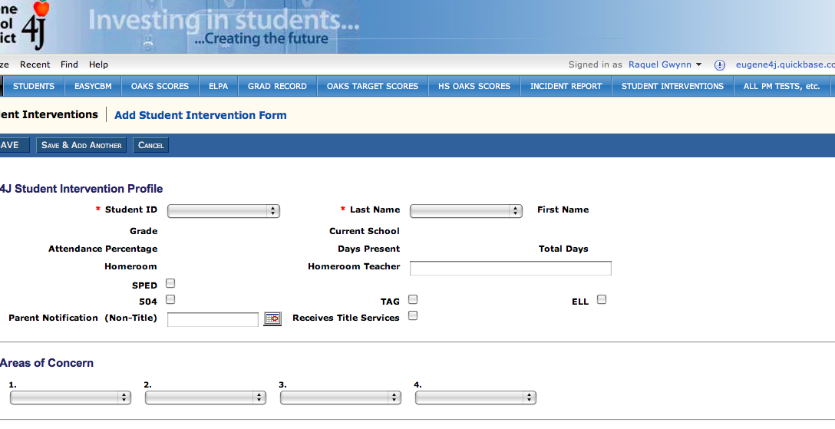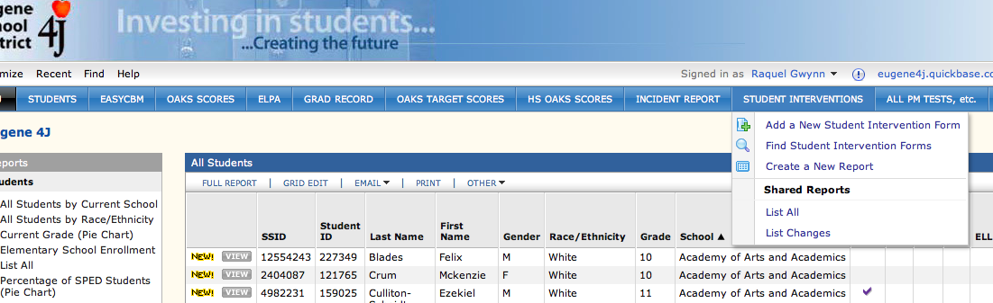

**Step 2:**

Click on Add a New Student Intervention Form

**Step 3:**

Click on Student ID

**Quick Start Guide to Creating the Quickbase**

**Student Intervention Profile Form**

**How do I find the form?**

It is on Quickbase.  You will need to have a license to access Quickbase.  The TLC, principal and Title Coordinators all have licenses for Quickbase access.  The website login is- <https://eugene4j.quickbase.com/db/main?a=signin&_c=jtf6r7>

**Step 1:**

Click on Student Interventions