Using the following documents and your knowledge of the time period, evaluate the extent to which the social and political standing of Black Americans and women improved between 1877 and 1929.

DOCUMENT 1
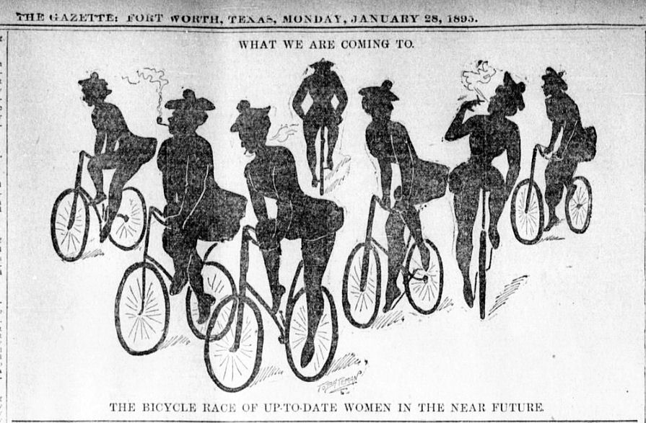

DOCUMENT 2
Speech Before Congress on Women’s Suffrage (1917)
Carrie Chapman Catt, woman’s suffrage leader

Woman suffrage is inevitable…
First, the history of our country. Ours is a nation born of revolution, of rebellion. Nations had been ruled by kings and for kings, while the people served and paid the cost. The American Revolutionists boldly proclaimed…"Taxation without representation is tyranny," [and] "Governments derive their just powers from the consent of the governed…"
Eighty years after the Revolution, Abraham Lincoln welded those two maxims [truths] into a new one: "Ours is a government of the people, by the people, and for the people." Fifty years more passed and the president of the United States, Woodrow Wilson, in a mighty crisis of the nation, proclaimed to the world: "We are fighting for the things which we have always carried nearest to our hearts: for democracy, for the right of those who submit to authority to have a voice in their own government."…
With such a history behind it, how can our nation escape the logic it has never failed to follow, when its last unenfranchised [not allowed to vote] class calls for the vote?
…We know [we] will meet opposition. There are a few "women haters" left, a few "old males of the tribe… whose duty they believe it to be to keep women in the places they have carefully picked out for them. … There are women, too, with "slave souls" and "clinging vines" for backbones. There are female dolls and male dandies. But the world does not wait for such as these, nor does liberty pause…

DOCUMENT 3

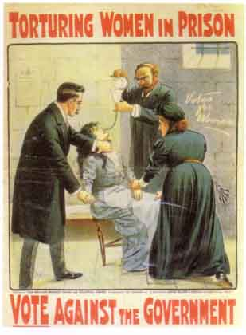
Women suffragettes were jailed for their protests. Sometimes they went on hunger strikes in prison and were force fed.

HUNGER STRIKER IS FORCIBLY FED; Miss Alice Paul, a Suffragist Picket, Is Greatly Exhausted After the Ordeal. HAD FASTED FOR 78 HOURS Washington Officials Said She Would Die Unless Strenuous Measures Were Taken.

Headline from New York Times, 1917

DOCUMENT 4
1920s Flapper
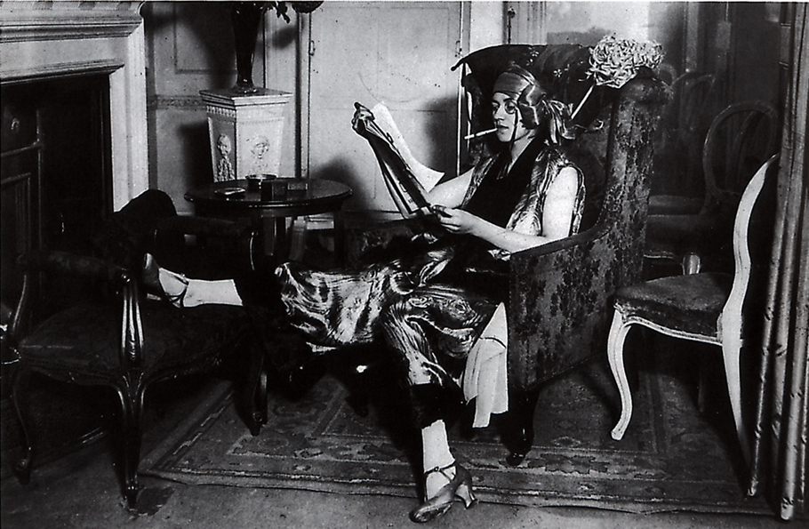

DOCUMENT 5

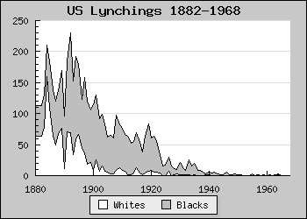

DOCUMENT 6
Major Taylor, 1890s

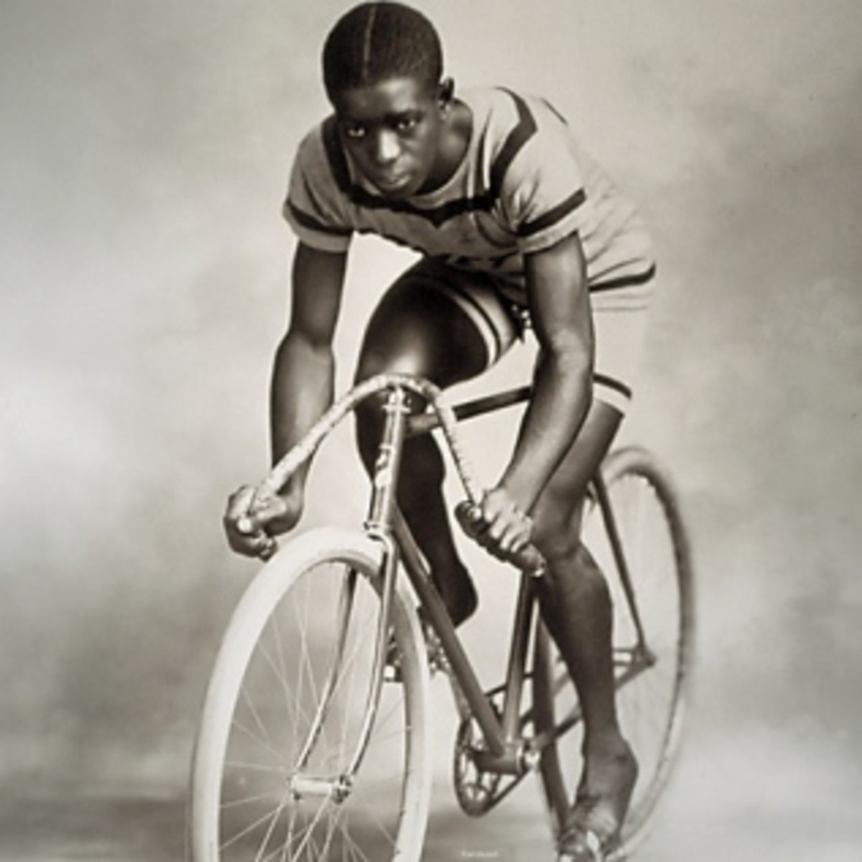

DOCUMENT 7
MY LORD, WHAT A MORNING, William Waring Cuney, commemorating Jack Johnson’s 1910 victory over Jim Jeffries
Oh, my Lord
What a morning,
Oh, my Lord,
What a feeling,
When Jack Johnson
Turned Jim Jeffries
Snow-white face
Up to the ceiling.
Yes, my Lord,
Fighting is wrong,
But what an uppercut.
Oh, my Lord,
What a morning,
Oh, my Lord
What a feeling,
When Jack Johnson
Turned Jim Jeffries
Lily-white face
Up to the ceiling.
Oh, my Lord
What a morning,
Oh, my Lord
Take care of Jack.
Keep him, Lord
As you made him,
Big, and strong, and black.

DOCUMENT 8
W.E.B. Du Bois, after World War One (1918) (excerpts)

We return from the slavery of uniform, which the world's madness demanded us, to don the freedom of civil garb. We stand again to look America squarely in the face. This country of ours, despite all its better souls have done and dreamed, is yet a shameful land.
It lynches.
It disenfranchises its own citizens. [disenfranchises – denies the right to vote]
It encourages ignorance. It steals from us.
It insults us.
We return from fighting.
We return fighting.
Make way for Democracy! We saved it in France, and by the Great Jehovah, we will save it in the United States of America, or know the reason why.

DOCUMENT 9

America (1922), Claude McKay, immigrant from Jamaica
Although she feeds me bread of bitterness,
And sinks into my throat her tiger's tooth,
Stealing my breath of life, I will confess
I love this cultured hell that tests my youth!
Her vigor flows like tides into my blood,
Giving me strength erect against her hate.
Her bigness sweeps my being like a flood.
Yet as a rebel fronts a king in state,
I stand within her walls with not a shred
Of terror, malice, not a word of jeer.
Darkly I gaze into the days ahead,
And see her might and granite wonders there,
Beneath the touch of Time's unerring hand,
Like priceless treasures sinking in the sand.

DOCUMENT 10
State Historical Society of Missouri
In 1924, playing for the Mobile (Alabama) Tigers, Satchel Paige won an estimated thirty games with only one loss. In 1926 he joined the professional Chattanooga (Tennessee) Black Lookouts for two successful seasons. Paige then spent the next several years going from team to team in search of a more lucrative paycheck.

When not playing with a team, Paige and other black players formed freelance barnstorming teams that toured the country playing other teams in exhibition games to make extra money…Life on the road was not easy for black players and they regularly endured racist taunts from spectators. Due to segregation, they were not allowed to stay at hotels where whites lodged or dine at restaurants used by whites…

Despite [this], Paige attracted white spectators with his dazzling pitching skills. He could throw a variety of pitches with accuracy and speed that few could match. He gave his pitches colorful names such as “jump ball, bee ball, screw ball, woobly ball, whipsy-dipsy-do, a hurry-up ball, a nothin’ ball, and a bat dodger.”

