Station 1: Copy and complete the stem-and-leaf plot below for the following set of data: 64, 87, 52, 12, 17, 23, 45, 88, 45, 92, 62, 76, 77, 34, and 53.
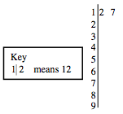

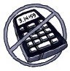
Station 2: Add or subtract.
A: 9.67 + 5.22
B: 4.2 + 1.903
C: 97.1 − 35.04

Station 3: Copy the sequences and fill in the missing numbers. Explain the pattern in words.
A: 5, 14, 23, 32, 41, ____, ____, ____
B: 3, 6, 12, 24, 48, ____, ____, ____

Station 4: How many different rectangles can you draw with an area (number of “tiles”) of 28? What is the perimeter (number of “toothpicks”) of each one? Show your work.
Station 5: Use your knowledge of place value to round the decimals to the specified place in parts (a) through (c). Place the correct inequality sign (< or >) in parts (d) through (f).
A: 17.1936 (hundredths)
B: 0.2302 (thousandths)
C: 8.256 (tenths)
D: 47.2__47.197
E: 1.0032__1.00032
F: 0.0089__0.03
Station 6: Find the perimeter and area of each figure below.
A: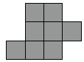

B: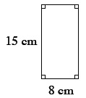
C: Sketch at least one way to rearrange the tiles in part (a) so that the shape has a larger perimeter. What is the perimeter of your new shape?
Station 7: Complete these generic rectangles. Then write a numerical sentence showing the original multiplication problem and the product.
A: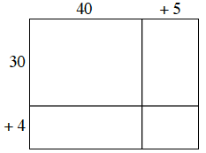

B: 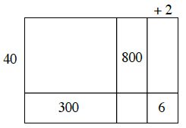

Station 8:
a. You have a hundred block, 6 ten-blocks, and 4 one-blocks. Draw a figure that minimizes the total perimeter of the figure. What is the area? What is the perimeter?

b. You have a hundred block, 3 ten-blocks, and 2 one-blocks. Draw a figure that maximizes the total perimeter of the figure. What is the area? What is the perimeter?

c. You have two hundred blocks, a ten-block, and 3 one-blocks. Draw a figure that minimizes the perimeter of the figure. What is the area? What is the perimeter?

