When logged in to your Absence Management account: 1)Click on Account under the Navigation menu, 2)Under personal Info, fill in your time in the Absence Times and the Sub Report Times and make sure to leave out your 30 min unpaid lunch break, 3)Save changes!
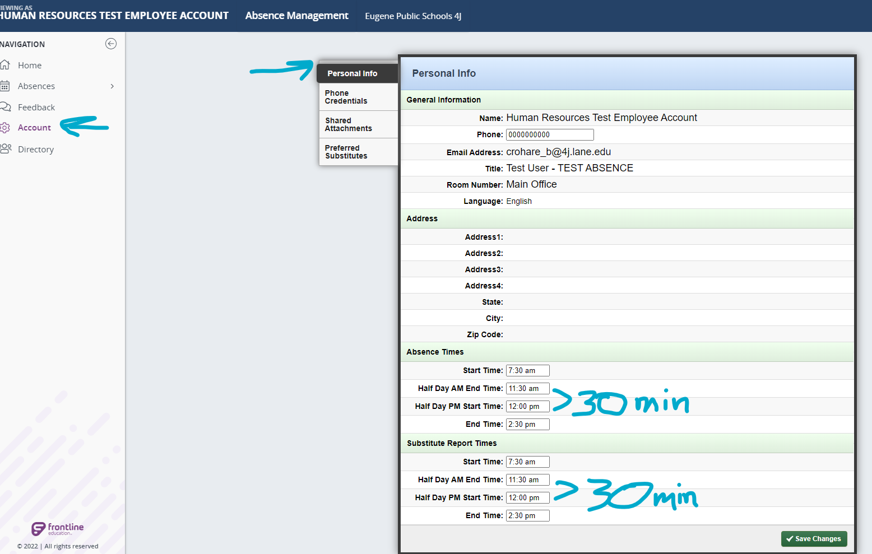
Once you have saved your changes, any absences you enter will match your default time and automatically deduct a 30 min lunch from the sub time- You will not see the deduction, but the sub will be paid correctly. Using the above example, the time will show 7:30-2:30 (7 hours) but the sub will be credited 6.5 hours.

