Option #4: Artivism Poster Project

Roots in ChicanX Movement
•Chicano Movement of the 1960s was a struggle for civil rights and empowerment for Mexican-Americans.
•In 2008, theorists Chela Sandoval and Guisela Latorre developed a concept–artivism— which describes combining art with political activism.
•They write,
–“Multidimensional meaning systems…create the foundation of Chicana/o social activism… [Concepts] must provide access to a myriad of cultures, languages, and understandings, thus requiring the ability to negotiate multiple worldviews.”
–“Chicana/o artivism…expresses a consciousness aware of conflicting and meshing identities, and uses these to create new angles of vision to challenge oppressive modes of thinking.” (83)

•An example of artivism is Esther Hernández’s poster called Sun Mad, which emerged from her own experience with her family’s struggle for farmworkers’ rights in the San Joaquin Valley in California.

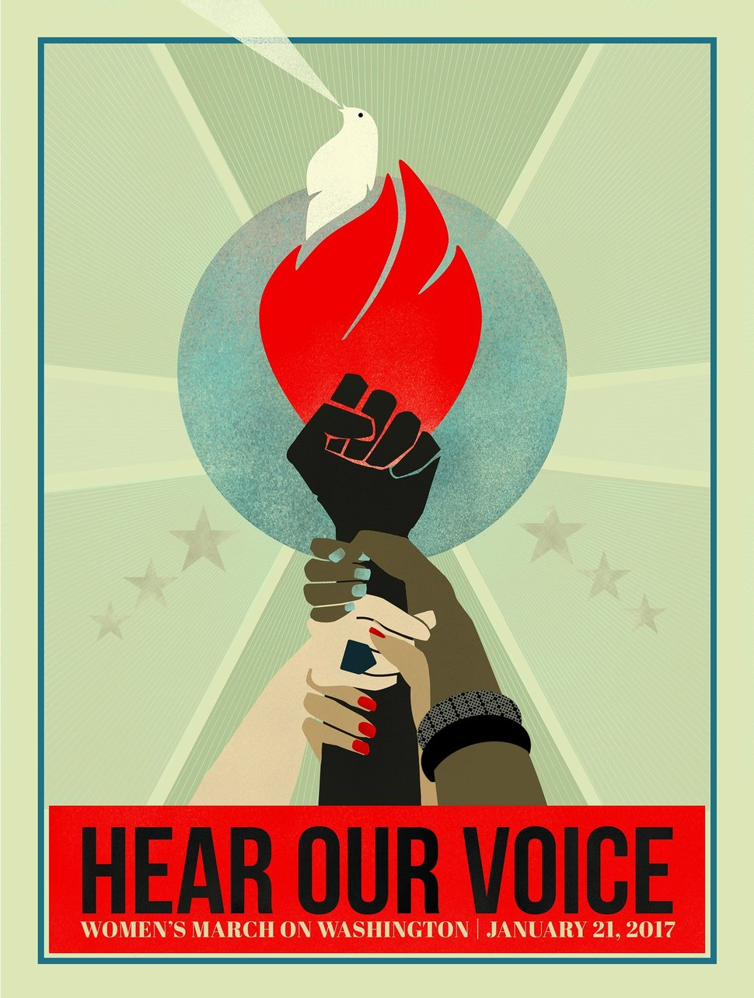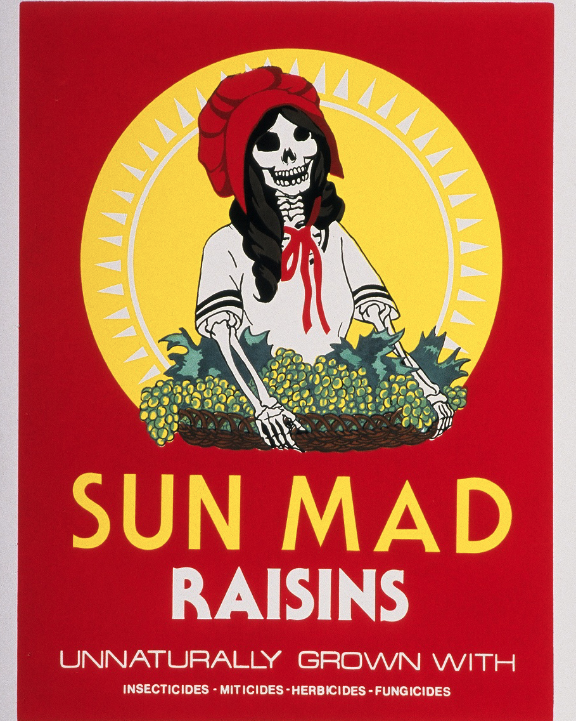

Another example of “artivism” is the poster for the Women’s March on Washington.
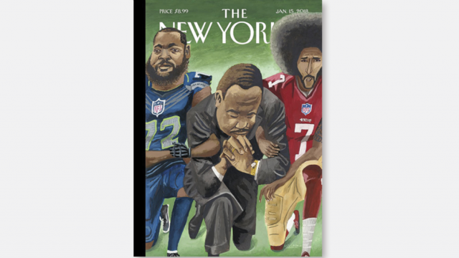

The latest cover of “The New Yorker” is another excellent example of artivism. It depicts Martin Luther King, Jr. kneeling with two of the most prominent NFL players to take a knee to protest police brutality of black men, Colin Kaepernick and Michael Bennett. King is kneeling, but his hands are also locked in prayer and he his eyes are closed, while his arms are locked with the other two men. What do you think this piece of “artivism” is trying to say?

- For your final poster, choose an issue that is important to you and that you want to see justice for in your lifetime.
- Take time to do some research on your topic (make sure your sources are reliable and credible) so that you can educate yourself (and then others) about the most important aspects of your chosen issue
- Then, create an “artivism” poster—a piece of art that combines artistic elements with political activism. Your poster should present your issue so that the elements of injustice are apparent. If possible, you should also try to include a message about how you want to see this issue addressed or what you want to see change in the future—all of this should be done through the artwork of the poster.

Here is a short list of possible topics and issues you could address, or of course you can choose any current issue of injustice about which you feel passionately.

- DREAM act
- Deportation of undocumented people
- Gender Equality
- Gay Marriage
- LGBTQ/Transgender Rights
- Police Brutality/Controversy surrounding “take a knee” campaign in the NFL
- Refugee/Immigration Issues
- Black Lives Matter
- Dakota Access Pipeline/ Native American land rights
- Climate change/ protection of natural lands and resources
- Animal cruelty
- Reproductive Rights/Abortion rights/ Pro-Life Movement
- Death penalty/ Problems in the criminal justice system
- Equitable access to health care
- Issues surrounding cycles of poverty/ class struggle

