Map It ON-LINE ! Name Jim Bob
After The Map: Think About It Date Oct. 1st

Directions: Please answer the following questions.

- Neighborhood: Down town area

- Photographs:
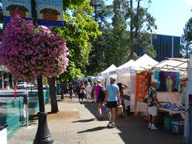 | 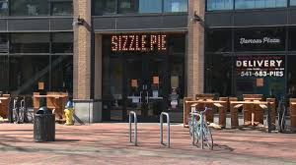 | 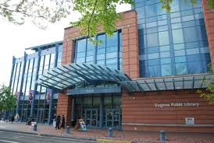

- What was in abundance in this neighborhood? Resturants , businesses, public service

- What was lacking in this neighborhood? Playgrounds , food store like Albertson , parks

- Are there any advantages of living in this neighborhood? Easy to get anywhere because your close to LTD bus station . Many resturants and food choices.

- Are there any disadvantages of living in this neighborhood? You may need to go a bit out of your way to get to a store. Not so many parks or green areas. Biking is hard to do due to traffic and many people.

If you could give one bit of advice to someone moving into this neighborhood, what would that advice be? Make sure you look carefully for an affordable apartment, as many of them are very expensive.

