Name:____________________________Date:______________ Period: __________
Algebra I - Chapter 8 Review packet
1.) Find the y-intercept, x-intercepts, and vertex for the following equation
y = x2 – 5x - 24.

2.) Mr. Lee's class studied the tile pattern below. Monica claimed that the pattern is not linear. Was she correct? Write a rule to describe how the figure number relates to the number of tiles in the pattern and explain your answer.

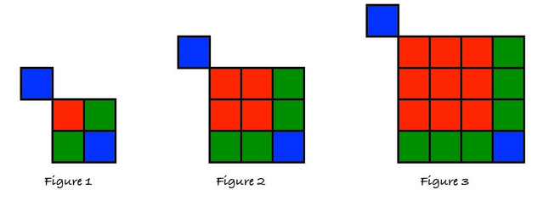

3.) Write an algebraic equation for each figure below to express the relationship, "Area as a product equals area as a sum."
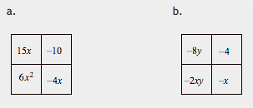
4.) Write a quadratic rule that represents the table below. Explain how you created your equation. (remember to use your intercepts)
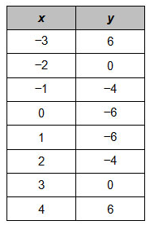

5.) In order to solve x2 + 20x = 2 by completing the square, what value must be added to both sides?

6.) Without using a calculator, simplify using only positive exponents.
- (9^{1/2}x²y)(27^{1/3}y⁻¹) B. (x^{1/2}) ⁻² C. 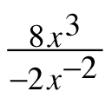

7.) Multiple Choice: Jenny is solving the equation x2 – 16x = 9. Which number should she add to both sides of the equation to complete the square? Explain your reasoning or show the work that helped you decide on your answer.
A. 16 B. 8 C. 64 D. 9

8.) Factor each of the following completely.
a. 9x2 – 49 b. 5a2 – 125

9.) Use the Zero Product Property to calculate the roots (x-intercepts) of the polynomials below.
a. (x – 9)(6 – 2x)
b. x(12 – 5x)
c. 4x2 + 23x – 6

