4-Year Graduation Rates for the Class of 2023 by Elementary School of Origin
- The 4-year graduation rate for the class of 2023 excluding charter schools and alternative programs was 80.2%
  - The graduation rates were very different according to elementary school of origin, being almost 98% for one school while being almost 70% for another

- Students in elementary schools with higher levels of need as measured by the 4J Needs Index tended to have significantly lower graduation rates 7 years after leaving elementary school
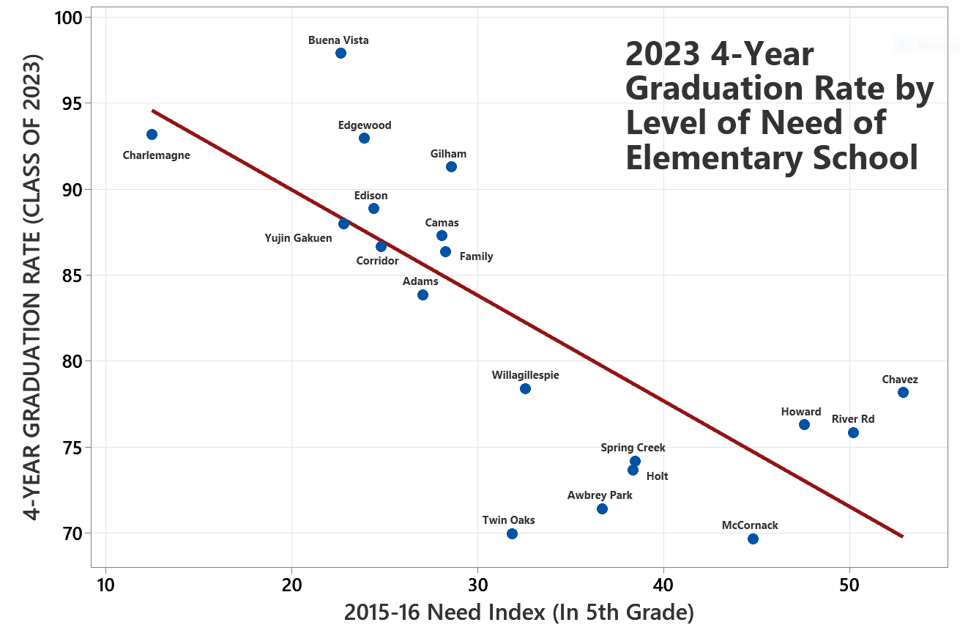
- Students in elementary schools with higher persistence rates to high school in 4J (lower mobility) tended to have significantly higher graduation rates 7 years after leaving elementary school
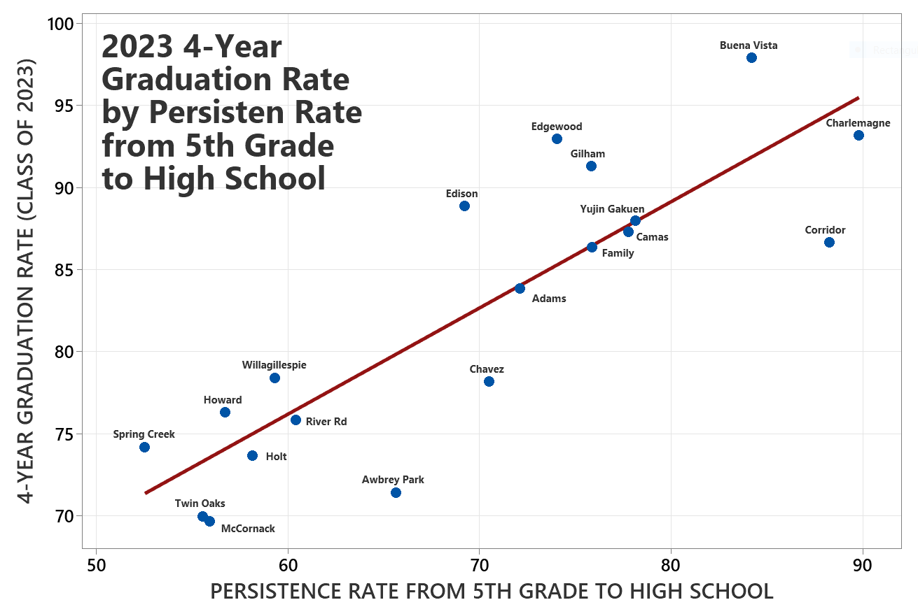
- Underlying data:

