FIRST TIME USER - REGISTERING FOR PROFESSIONAL DEVELOPMENT ACTIVITIES IN THE 4J PD MANAGEMENT ONLINE SYSTEM
- Accessing the system for the first time:
- Navigate to 4jpd.net (or 4jlane.truenorthlogic.com)
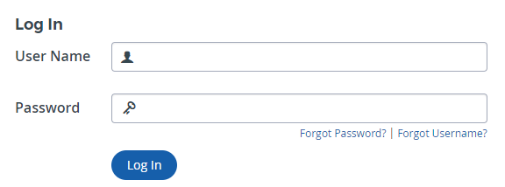
- Enter your 4J email user name (your 4J email address without the @4j.lane.edu part)
- Click on “Forgot Password”
- You will receive a message in your 4J email that will allow you to choose your password

- Accessing the System after the first time:
- Navigate to 4jpd.net (or 4jlane.truenorthlogic.com)
- Enter your 4J email user name (your 4J email address without the @4j.lane.edu part)
- Enter your 4JPD password
- Click “Log In”

- Asking questions or other support about the 4J management system:
- Call Shelly Williams at x7556
- Send an email to 4jpd@4j.lane.edu to reach the 4J PD workgroup or
- Click on the ? icon near the top right of the 4jpd.net homepage to reach the website provider

- Seeing all the PD activities available:
  - Click on the “Home” tab if you are not in your 4JPD homepage:
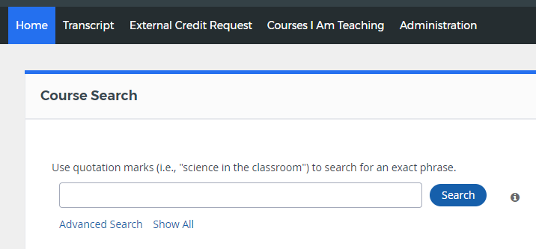
  - In the “Course Search” box near the top left of the homepage, click on “Show All”
  - You will see a list of all PD activities available to you:
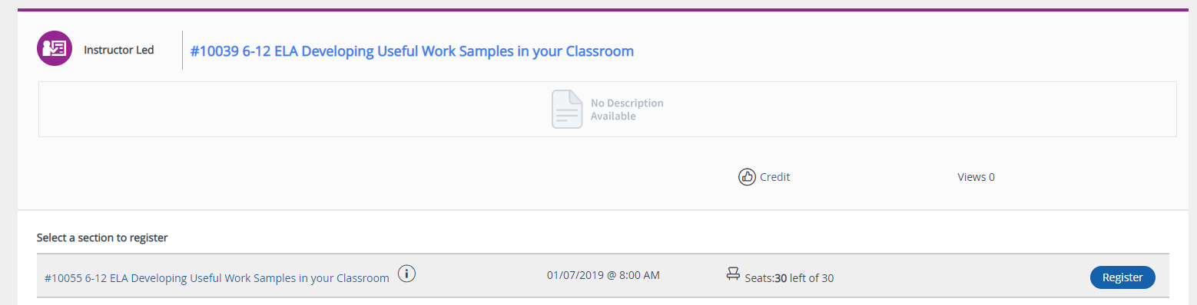
- You can also use the search bar to narrow down your choices
- You can search the course by title

- Registering for a PD activity:
  - In the list of all the PD activities available to you, navigate to the one you want to register for and check the information about sections, the different opportunities to access that PD activity:
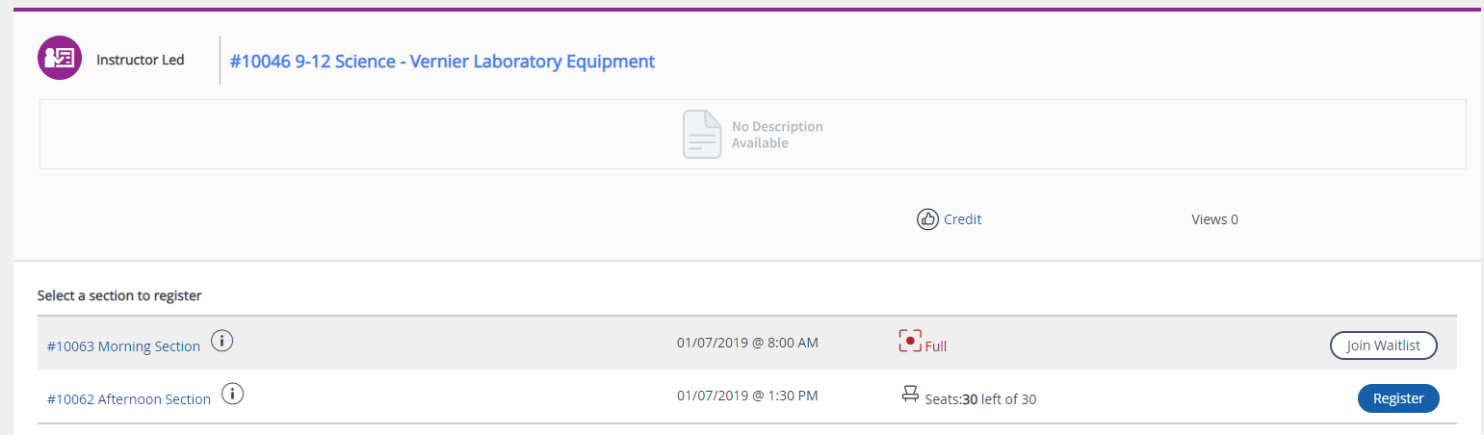
  - If the section is not full, click on “Register” to register
  - If the section is full, click on “Join Waitlist” to be included in the waitlist

