**STUDENT GOAL ONE:**

Type of Student Goal: Growth ___X___ Social-emotional _______

**1. Target Population:**

___ grade student in Room ___ (entire class)

**2. Baseline Data & Assessment Tools:**

Fall benchmark writing work sample

**3. Time Interval:**

September through May

**4. Teaching/Learning Standards and Strategies:**

Use the district adopted writing curriculum, Being A Writer, for writing instruction, in conjunction with the building agreed upon writing standards, common practices, strategies and tools found in the Howard Writing Resource Binder.

**5. Assessments:**

Fall and spring benchmark writing work samples.

**6. Rationale for Growth Targets:**

Review of students’ previous writing assessment results indicated many students are not meeting benchmark. Writing has been a building area of focus along with being on of the goal areas on our School Improvement Plan. Additionally, the school district is focusing on writing instruction and has adopted a district-wide

**7. Growth Assessment Tool(s) by Category:**

____ State/national standardized test:

____ Common national or other approved measure:

__X__ Schoolwide or classroom-based measure: Schoolwide writing benchmark assessment graded using the state writing rubric.

**Statement of Student SMART Goal:**

All students will make measurable progress in writing. Each student will improve by one performance level from fall to spring, or meet benchmark, on their writing work sample in two or more areas of the building adopted writing rubric (state scoring guide for 3-5 and visual scoring guide for K-2).

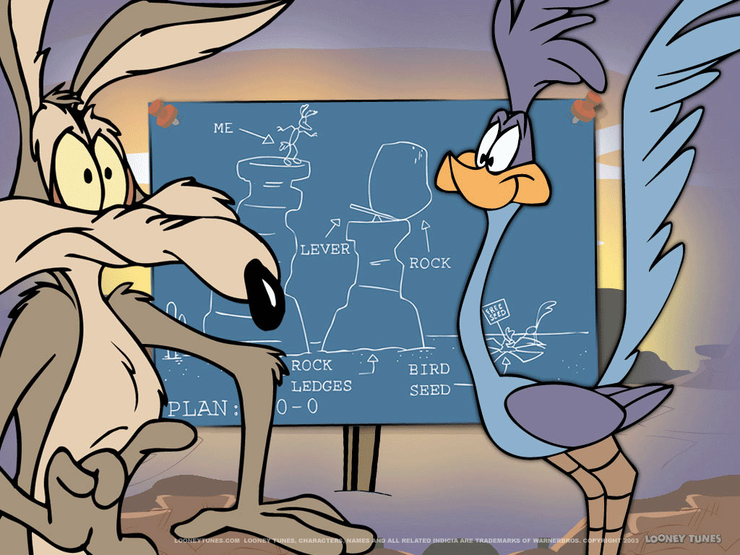

**STUDENT GOAL TWO:**

Type of Student Goal: Growth ___X___ Social-emotional _______

**1. Target Population:**

___ grade student in Room ___ (entire class)

**2. Baseline Data & Assessment Tools:**

Fall easyCBM Math Assessment

**3. Time Interval:**

September through May

**4. Teaching/Learning Standards and Strategies:**

Use the Investigations curriculum with appropriate supplemental material as needed to teach to the Common Core State Standards.

**5. Assessments:**

Fall and spring easyCBM math assessment

**6. Rationale for Growth Targets:**

Review of students’ previous math assessment results indicate that math was the lowest subject area tested. Math is additionally a goal area on our School Improvement Plan.

**7. Growth Assessment Tool(s) by Category:**

__X__ State/national standardized test: easyCBM Math in fall and spring

____ Common national or other approved measure:

____ Schoolwide or classroom-based measure:

**Statement of Student SMART Goal:**

All students will demonstrate measurable growth in mathematics. All students will meet typical growth rates identified by the easyCBM math assessments. Furthermore, at least 70% of students will score at grade level or better (above the 30%) on the spring easyCBM math assessment.

**LICENSED FACULTY PROFESSIONAL PRACTICE GROWTH PLAN**

(Note: This section is not completed by temporary faculty members.)

**Licensed Faculty Professional Practice Goal(s) and Activities: Support**

I will work to increase my skills in technology integration to support student learning. My plan is as follows:

* Participate in related trainings and professional development (school district and building level trainings).
* Share my own technology integration success, ideas and skills with colleagues.
* Seek out and try new instructional ideas, resources and practices learned from peers, trainings, online or from other sources of learning.

