STUDENT GOAL ONE:

Type of Student Goal: Growth ___X___ Social-emotional _______

1. Target Population:
___ grade student in Room ___ (entire class)

2. Baseline Data & Assessment Tools:
Fall benchmark writing work sample

3. Time Interval:
September through May

4. Teaching/Learning Standards and Strategies:
Focus writing instruction toward the building agreed writing standards and use the common practices, strategies and tools found in the HowardWriting Resource Binder.

5. Assessments:
Fall and spring benchmark writing work samples

6. Rationale for Growth Targets:
Review of students’ previous writing assessment results indicated many students are not meeting benchmark. Writing has been a building area of focus along with being on of the goal areas on our School Improvement Plan.

7. Growth Assessment Tool(s) by Category:
____ State/national standardized test:
____ Common national or other approved measure:
__X__ Schoolwide or classroom-based measure: Schoolwide writing benchmark assessment graded using the state writing rubric.

Statement of Student SMART Goal:
All students will make measurable progress in writing. Each student will improve by one performance level from fall to spring on their writing work sample in two or more areas of the building adopted writing rubric (state scoring guide for 3-5 and visual scoring guide for K-2). Furthermore, 70% of students will score at benchmark or better overall.

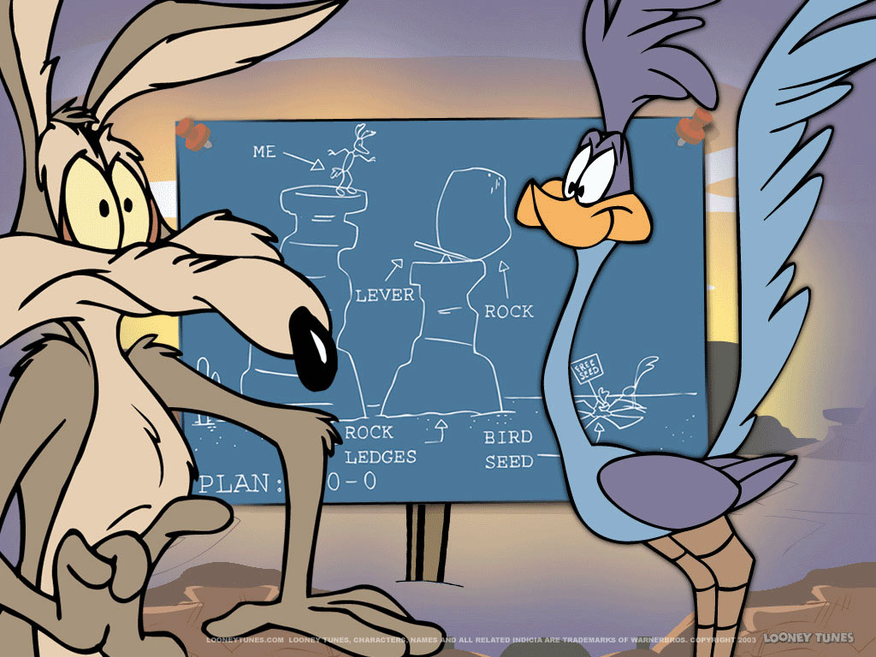

STUDENT GOAL TWO:

Type of Student Goal: Growth ___X___ Social-emotional _______

1. Target Population:
___ grade student in Room ___ (entire class)

2. Baseline Data & Assessment Tools:
Fall easyCBM Math Assessment
2012-2013 OAKS math scores and growth targets (4/5 only)

3. Time Interval:
September through May

4. Teaching/Learning Standards and Strategies:
Implement the new Investigations curriculum with appropriate supplemental material as needed.

5. Assessments:
Fall and spring easyCBM math assessment
OAKS math assessment (3/4/5 only)

6. Rationale for Growth Targets:
Review of students’ previous math assessment results indicate that math was the lowest subject area tested. Math is additionally a goal area on our School Improvement Plan.

7. Growth Assessment Tool(s) by Category:
__X__ State/national standardized test: easyCBM Math in fall and spring (KG-5 Grade), OAKS (for grades 3/4/5)
____ Common national or other approved measure:
____ Schoolwide or classroom-based measure:

Statement of Student SMART Goal:
All students will demonstrate measurable growth in mathematics. All students will meet typical growth rates identified by the easyCBM math assessments. Furthermore, at least 70% of students will score at grade level or better on the spring easyCBM math assessment.

3rd Only
70% of students will meet or exceed proficient on the OAKS math assessment.

4/5 Only
90% of students will meet their OAKS math growth targets.

LICENSED FACULTY PROFESSIONAL PRACTICE GROWTH PLAN
(Note: This section is not completed by temporary faculty members.)

Licensed Faculty Professional Practice Goal(s) and Activities: Support

I will collaborate with colleagues to increase my skills in community building, specifically in implementation of the Caring for Kids program. My plan is as follows:

- Teach the Caring School Community curriculum during required homeroom times.
- Participate in all related trainings and PD (Developmental Studies Center, school district and building).
- Integrate and supplement with other materials, strategies and activities (2nd Step, PBIS Lessons, Cooperative Learning, Tribes, etc.)

