WRITING

All students will make measurable progress in writing. Each student will improve by one performance level from fall to spring on their writing work sample in two or more areas of the building adopted writing rubric (state scoring guide for 3-5 and visual scoring guide for K-2). Furthermore, 70% of students will score at benchmark or better overall.

MATH

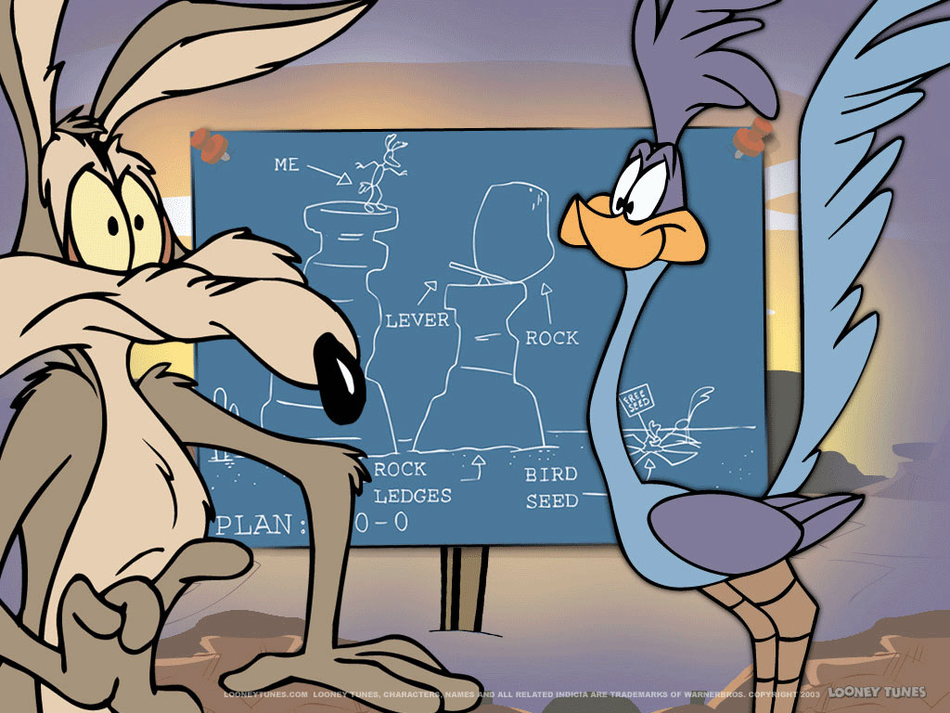
All students will demonstrate measurable growth in mathematics. All students will meet typical growth rates identified by the easyCBM math assessments. Furthermore, at least 70% of students will score at grade level or better on the spring easyCBM math assessment.

3rd Only
70% of students will meet or exceed proficient on the OAKS math assessment.

4/5 Only
90% of students will meet their OAKS math growth targets.

Professional Goal – Community Building

I will collaborate with colleagues to increase my skills in community building, specifically in implementation of the Caring for Kids program. My plan is as follows:

- Teach the Caring School Community curriculum during required homeroom times.

- Participate in all related trainings and PD (Developmental Studies Center, school district and building).

- Integrate and supplement with other materials, strategies and activities (2nd Step, PBIS Lessons, Cooperative Learning, Tribes, etc.)

