10.3 Day 2 - Paired Data or Two Samples

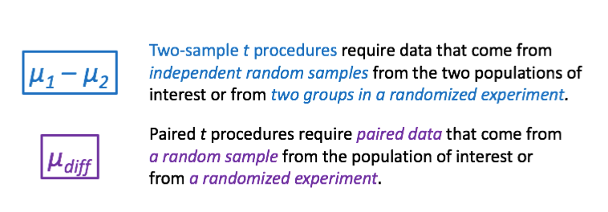

**Caution! The proper _____________ method depends on how the data were ______________.**

**To help decide between one and two sample $t$ procedures (intervals or tetst), you should ask yourself:**

1. How many samples do I have?

One:

Two:

2. Can any piece of data in the first group be compared to any piece of data in the second?

If yes:

If no:

3. Do they reference pairing the data?

Yes:

No:

Other things to look for:

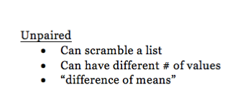

Paired

* Can’t scramble a list
* Same # of values in each
* “Mean difference”

Get Your Heart Beating

Activity on page 684

Experiment #1 Completely Randomized Design



Experiment #2 Matched Pairs Design

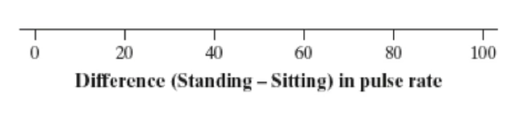

**Luke’s taco shop**

*Two samples or paired data?*

In each of the following settings, decide whether you should use two-sample $t$ procedures to perform inference about a difference in means **OR** paired $t$ procedures to perform inference about a mean difference. Explain your choice.

(a) Luke’s taco shop is considering a switch to a new tortilla that supposedly has a larger diameter. To test this claim, Luke takes a random sample of 50 of the old tortillas and 50 of the new tortillas and records the diameter of each.

(b) Luke’s taco shop wants to be sure that the new tortillas taste better than the old tortillas. Luke selects a random sample of 20 regular customers. Each customer is asked to try both tortillas and then record a “taste” score for each. The order in which the customers try the two tortillas is randomized.

(c) Luke’s taco shop is not sure whether to cook the tortillas in the oven or on the grill. The chefs want tortillas to cook as quickly as possible. Luke sets up an experiment taking a batch of 50 tortillas and randomly assigning half of them to be cooked one at a time in the oven and half of them to be cooked one at a time on the grill. The time it takes until ready to serve is recorded for each tortilla.

**Choosing the Correct Inference Procedures**





