**Review Problems for Algebra 2A - Trimester Exam**

Work on the following questions. Starting on question #7, show all work and answers on separate paper. Skip a line between problems. Check your answers often with the solutions.

Domain and Range

* 1. For each graph below, state whether it is a function or not. **Then** state the domain and the range for each of the graphs.

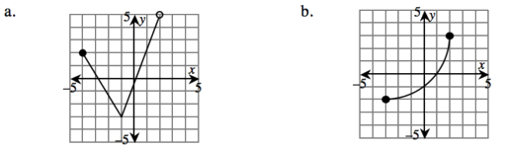

2. What are the domain and range of each relation below?

a. 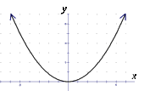 b. 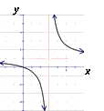 c. $y= -\frac{1}{x^{2}}$

Linear Functions

3. Cirlce the follwowing function which represent linear relationships.

a.        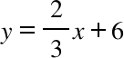         b. $y=x^{2}$         c.        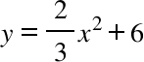 d.        

e. $y=x^{2}+3x+5$               f.        y = 5 g.        3x + 4y = 9

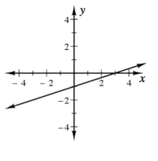

4. What is the equation for the following graph?

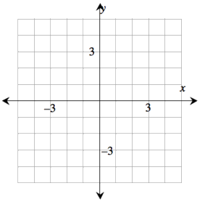5. Graph the equations $y=-\frac{1}{2}x-5$  and $x-2y=2$

on the same set of axes.

6. What is the equation of the line through the points (5, –1) and (–1, 2)? Show all work and explain how you know you are right.



Solving Linear Equations

7. Solve  for x. Clearly show your solution.

8. Find the error(s) in the solution below.

(2x + 5) – (5x + 4) = 6 – 2(x – 3)

2x + 5 – 5x + 4 = 6 – 2x – 6

–3x + 9 = –2x

–3x + 9 = –2x

x = 8

Function Notation

9. For , evaluate each of the following.

a.        f (3)         b.        f (–2)         c.        What is the value(s) of x for which f (x) = 25?

10. For , evaluate each of the following.

a.                                        b.           Find the value of x for which .

11. For 6x ³ + 5x ², Find the value of x for which $f(x)=0$

Factoring

12. Fred was trying to factor the following expression completely when he realized he did not know how to

get started. All he can remember is something about common factors first. Help him out by factoring the expression as completely as you can to create an equivalent expression.

$$4m^{4}-6m^{3}+2m^{2}$$

Quadratic Equations

***13. Solve*** *the following:*

a. (3*x* + 7)(4*x* – 7)(9874*x*) = 0         b.        *x*2 + 4*x* – 3 = 0 c. .

14. Anuar was solving an equation for x but admitted he really was not sure what he was doing. His work is

shown below. List any mistakes that Anuar made, then rework the problem correctly, showing all of your

work.

$$3x^{3}+6x^{2}-45x = 0$$

$$3x(x^{2}+2x-15)= 0$$

$$x^{2}+2x-15= 0$$

(x – 5)(x + 3) = 0

x = 5 or x = –3

15. Rewrite the following quadratic function in standard $y=ax^{2}+bx+c$.

$$y-8x-8=3\left(x^{2}+2x\right)+8x-9$$

Solve a System of Equations

16. What is the point of intersection of the graphs of these two lines? Clearly show an algebraic solution.

5x – 2y = –36

4x + 3y = –15

Sequences

*17. Consider the sequence 3, 6, 12 …*

1. *What kind of sequence is it? How can you tell?*
2. *Write a rule for this sequence.*

*18. Give the next three terms of the sequence below and write a formula for the nth term of the sequence. What*

*would you expect the 225th term to be really close to? Explain.*

*148, 144, 140 , ____, _____, _____, …*

Exponential Functions

19. Each table below represents an exponential function of the form . Complete each table on your

paper and find the corresponding rule.

|  |  |
| --- | --- |
| x | y |
| 0 | 3 |
| 1 |  |
| 2 | 108 |
| 3 |  |
| 4 |  |

|  |  |
| --- | --- |
| x | y |
| 0 | 3.1 |
| 1 | 4.34 |
| 2 | 6.076 |
| 3 |  |
| 4 |  |

20. A small (fictional) country had a population of 2,254,000 people in the year 2000. If the population grows steadily at a rate of 3.5% each year, what is the expected population of this country in the year 2015 to the nearest 1000?

21. A car is currently worth $9000. Each year it depreciates (loses value) by 12%.

1. *What will the car be worth in 5 years?*
2. *If the car was purchased 3 years ago, what was the purchase price?*

Convert an equation of a parabola to graphing form

22. Without graphing, what is the vertex of the parabola represented by the equation $y={(x-5)}^{2}-1$? How do you know? Is the vertex a maximum or a minimum? How do you know? Make a sketch of the graph of this parabola based on this information.

23. Consider the equation .

1. *Is it easier to find the x-intercepts of this equation or the vertex? Why?*
2. *What are the x-intercepts of this equation? Show your work.*

24. Rewrite each of the following quadratic equations in graphing form. Then state the vertex.

a.                                b.         

Mathematical Modeling with Parabolas

25. Darren was tossing a ball and he noticed that the path of the ball was a parabola, so he quickly took measurements. The highest point the ball reached was 5 feet and it landed 6 feet from where he was standing. Sketch a graph and write an equation that describes the path of the ball. Be sure that your variables are clearly defined or labeled on your graph.

Exponent Fun (be sure to have your exponent rules written down)

26. Simplify each expression. Be sure that your answer has only positive exponents.

a.                b.         c.                 d.

27. You are trapped on a desert island by a band of Math Fanatics who will only let you off if you can simplify the expression ${\left[{\left(\frac{1}{4}\right)}^{\frac{1}{2}}\right]}^{-2}$   without your calculator. Show your work in detail and explain in words how you arrived at your answer.

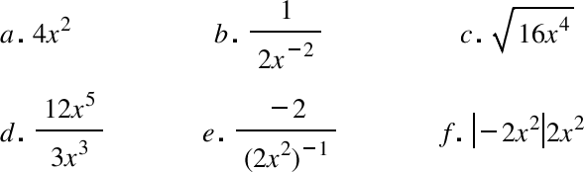28. Which of the expressions below are equivalent to 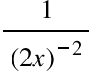? Make sure you find all of the correct answers.

Anyalyze a function

29. Investigate the function $f(x)= \frac{2}{x-3}$ as far as domain, range, asymptotes

Calculate x- and y-intercepts

30. What are the x- and y-intercepts for 3x + 5y = 18? Show your work and explain your thinking clearly.

31. Use at least two methods to find the x-intercepts of the graph of

32. Describe how you would determine the x- and y-intercepts of any equation and then use your method to determine the intercepts of $g(x)=\sqrt{x+5}$.

Write transformations of functions

33. How does changing the equation $x^{2}+y^{2}=16$  to ${(x-7)}^{2}+{(y+3)}^{2}=36$   change the position and the size of the circle.

34. The parabola $y=x^{2}$ is shown on the graph to the left. How can its equation be changed to shift the parabola three units to the left and five units down (as shown in the graph above right)?

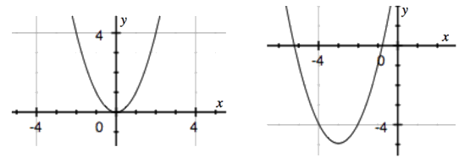

Re-arrange Equations

35. Solve  for x. Be sure to show all of your work.

36. Rewrite each of the following equations so that you could enter them into the graphing calculator. In other words, solve for y.

a.        x – 3(y + 2) = 6                                b.          c.        

37. Rewrite the equation below so that it is solved for x.

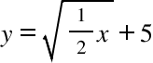

Multiply or Divide Rational Expressions

38. Simplify the expressions below.

a.        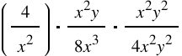         b.         c. 

Add or Subtract Rational Functions

39. a.  b.  c. 

Miscellaneous Equation Solving (showing steps, **be sure to show any extraneous solutions**).

40. a. 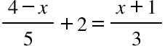 b.  c.                 d.        

Solve 1-variable inequalities

41. Solve the following inequalities. Remember that you can check your solutions with your graphing

calculator.

a.        2x – 4 ≤ 12          b.        

Solve 2-variable inequalities (by graphing)

42.

a.       5x - 2y < 10 b.        y < $0.05x^{3}$