**TRANSPORTATION AND DROP OFF /PICK UP CHANGES FOR 2015-2016**

**BUS LANE LOCATION CHANGE**

Bus will drop off students in front of the school beginning this year**.**

**PICK UP AND DROP OFF LOCATIONS**

We created a new drop off lane by the parking lot where bus zone was located.

We are now asking that parents drive through the parking lot for pick up or drop off. Please note that we have reversed the entry and exit of the parking. These changes were made to create a safer way to get children to and from school.

**We request you no longer use the street for pick up or drop off**.

This change will create a safer environment for our children and our neighbors will greatly appreciate this adjustment.

**NO PARKING/STOPPING ON STREET**

**NO PARKING/STOPPING ON STREET**

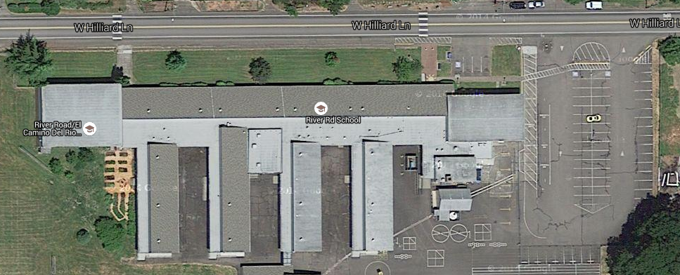

**BUS LANE- NO CARS**

**STUDENT DROP OFF LANE**