Chapter 8 Review
Physical Science - Matter

1. What is the smallest particle of an element that retains the chemical identity of the element?

2. There are many different ways to classify matter, but one way is to use only two categories for ALL matter. All matter can be classified as either:

3. What is the difference between a mixture and a compound?

4. What are the two types of mixtures? Describe the difference.

5. Name and describe the four states of matter.

5. How are physical properties defined? Give two examples of physical properties.

6. What is a physical change?

7. How is a chemical property different from a physical property?

8. What happens during a chemical change?

9. What are some indicators of a chemical change occurring?

10. What are intermolecular forces and how do they compete with temperature?

11. Explain the difference between boiling and evaporation

12. Define accuracy.

13. What phases of matter can flow? Explain.

14. What is condensation?

15. What is sublimation?

16. What is the system of measurement all scientists use and why?

17. How many significant figures in the following numbers?

- 0.00467 kg
b. 6000 mL
c. 0.330 cm
18. Convert the following measurements.
a. 15 cm to m

- 250 g to mg

c. 6800 L to kL

19. What is the jerky motion of particles called?

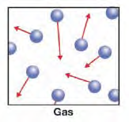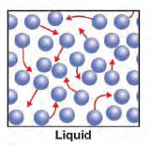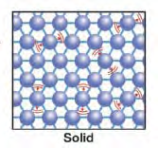

20. Identify the phases above.

21. Explain the strength of the intermolecular forces for each of the phases.

22. What is happening at the flat areas of the graph?
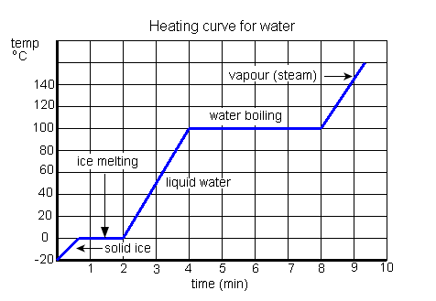
Essay Prompt

Why is the Kelvin scale more useful to scientists than the Celsius scale?

