Physical Science – Matter Name:____________________________Per:____

The Alkaline Earth Metals Lab

Background Information:
The arrangement of the elements in the periodic table is one of the most important achievements in modern chemistry. The physical and chemical properties of elements change in a regular pattern as you go both across the rows and down the columns of the periodic table. As a result, when elements close to each other in a row or column are compared, they have many of the same properties. However, when elements farther away from each other in a row or column are compared, they have more dissimilar properties.

The elements in Group 2 of the periodic table are known as the alkaline earth metals. Like all members of a group, or family, of elements, they have certain properties that change in a regular pattern within the group. One of these properties is the ability to form a precipitate, or solid substance, as a result of a chemical reaction. The precipitate cannot dissolve in water and eventually settles to the bottom of the container.

In this investigation you will compare the abilities of the alkaline earth elements to form precipitates as a result of a chemical reaction.

Materials: (per group)
- Safety goggles
- Spot plate
- Sheet of notebook paper
- Dropper bottles of
  - Magnesium nitrate Mg(NO₃)₂
  - Calcium nitrate Ca(NO₃)₂
  - Strontium nitrate Sr(NO₃)₂
  - Barium nitrate Ba(NO₃)₂
  - Potassium carbonate K₂CO₃
  - Potassium sulfate K₂SO₄
  - Potassium chromate K₂CrO₄

Procedure:
- Place the spot plate in the center of a sheet of notebook paper so that there are four spots running down and three spots running across. See Figure 1.
- Along the side of the notebook paper next to each of the four spots, write the names of the four alkaline earth elements that are present in each nitrate compound listed in the materials you are using. Write them in the same order in which they are listed.
- Along the top of the notebook paper next to each of the three spots, write the names of the three substances that are combined with potassium in the materials you are using.

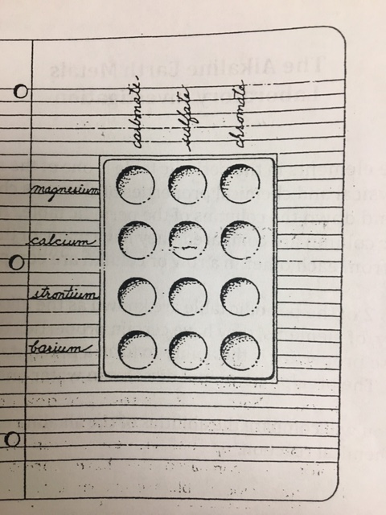 Figure 1

- Put on your safety goggles. Place three drops of potassium carbonate in each of the four spots under the word Carbonate. Place three drops of potassium sulfate in each of the four spots under the word Sulfate. Place three drops of potassium chromate in each of the four spots under the word Chromate.
- Take the dropper bottle of magnesium nitrate and place three drops in each of the three spots in the row labeled Magnesium. Repeat this procedure using the dropper bottles containing calcium nitrate, strontium nitrate, and barium nitrate. Be very careful not to mix the liquid from one spot with the liquid from another. Observe each spot carefully and record the result in the Data Table.
- After recording your results, wash your spot place thoroughly with soapy water and a brush.

DATA TABLE – Observations:
Alkaline Earth Metal | Carbonate | Sulfate | Chromate
Magnesium

Calcium

Strontium

Barium

Analysis and Conclusions:

- Was there evidence of a chemical reaction occurring in any of the spots? Explain your answer.

- Which alkaline earth metal (Magnesium, Calcium, Strontium, or Barium) formed the smallest number of precipitates?

- Which alkaline earth metal formed the greatest number of precipitates?

- What is the relationship between the number of precipitates formed and the location of the alkaline earth metal on the periodic table?

- If the ability of an alkaline earth metal to form a precipitate is an indication of its ability to chemically react with other substances, which is the most reactive metal?

The least reactive?

- List the alkaline earth metals in order of their chemical reactivity, starting with the most reactive.

- How does the order of the elements you listed in question 6 compare to their order on the periodic table?

Critical Thinking and Application:

- Why were you cautioned not to mix the solution in one spot with the solution in another spot on the spot plate?

- Group 1 in the periodic table is known as the alkali metals. Based on your investigation of the Group 2 elements, predict the comparative reactivity of the elements in Group 1 of the periodic table.

- If you had a solution containing a mixture of magnesium, strontium, and barium, how could separate the three elements? Hint: Review the information in the Data Table.

Physical Science – Matter Name:____________________________Per:____

The Alkaline Earth Metals Lab

Background Information:
The arrangement of the elements in the periodic table is one of the most important achievements in modern chemistry. The physical and chemical properties of elements change in a regular pattern as you go both across the rows and down the columns of the periodic table. As a result, when elements close to each other in a row or column are compared, they have many of the same properties. However, when elements farther away from each other in a row or column are compared, they have more dissimilar properties.

The elements in Group 2 of the periodic table are known as the alkaline earth metals. Like all members of a group, or family, of elements, they have certain properties that change in a regular pattern within the group. One of these properties is the ability to form a precipitate, or solid substance, as a result of a chemical reaction. The precipitate cannot dissolve in water and eventually settles to the bottom of the container.

In this investigation you will compare the abilities of the alkaline earth elements to form precipitates as a result of a chemical reaction.

Materials: (per group)
- Safety goggles
- Spot plate
- Sheet of notebook paper
- Dropper bottles of
  - Magnesium nitrate Mg(NO₃)₂
  - Calcium nitrate Ca(NO₃)₂
  - Strontium nitrate Sr(NO₃)₂
  - Barium nitrate Ba(NO₃)₂
  - Potassium carbonate K₂CO₃
  - Potassium sulfate K₂SO₄
  - Potassium chromate K₂CrO₄

Procedure:
- Place the spot plate in the center of a sheet of notebook paper so that there are four spots running down and three spots running across. See Figure 1.
- Along the side of the notebook paper next to each of the four spots, write the names of the four alkaline earth elements that are present in each nitrate compound listed in the materials you are using. Write them in the same order in which they are listed.
- Along the top of the notebook paper next to each of the three spots, write the names of the three substances that are combined with potassium in the materials you are using.

