Science Notebook Writing

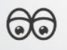 I observed __________­­

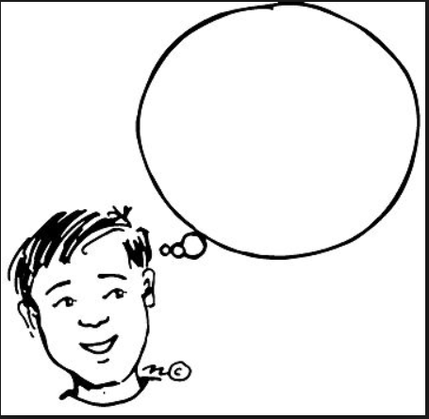 I think _________

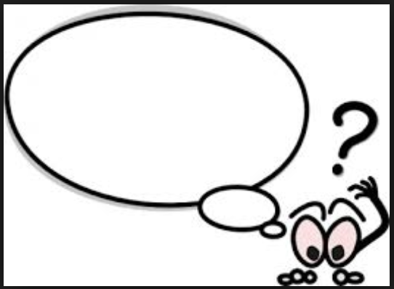 I wonder ________